# Capstone Project (CPRO306)

**ASSESSMENT 6 End of Project Deliverables**

#### **Project Title:** **Implementation and Integration Plan for Jot Bikes Management System**

|  |  |  |
| --- | --- | --- |
| **Team Members** | | |
| **No.** | **Name** | **SID** |
| **1** | **Thi Ngoc Quynh Ho** | **K220380** |
| **2** | **Erna Halim** | **K221578** |
| **3** | **Hendra Lim** | **K220685** |
| **4** | **Alyxandra Marie Sarmiento** | **K220411** |
| **5** | **Wangshu Tamang** | **K210810** |

Capstone Project (CPRO306) 1

**Project Title:** **Implementation and Integration Plan for Jot Bikes Management System** 1

**2. Project Overview** 4

**Objectives of the report** 5

**3. Integration Plan** 5

**Integration Approach** 6

**Tool Used for Integration** 6

**Front-End and Back-End Connectivity** 7

**Front-End** 7

**Back-End** 8

**Connectivity** 8

**4** **Server Configuration and Setup** 9

**Required Servers** 9

**Installation Procedures:** 9

**Configuration settings:** 10

**Security Configurations:** 11

**Running Status of Servers:** 11

**5.** **Data Management** 12

**Data Operations** 12

**Mechanisms for Inserting Data:** 12

**Mechanisms for Updating Data:** 13

**Mechanisms for Deleting Data:** 15

Data Security and Encryption 16

**6. System Testing** 19

**Testing Strategy** 19

**Test Results** 20

**7. Documentation** 29

**System Documentation** 29

**Customer manuals** 29

**Vendor User Manual** 34

**Admin User Manual** 38

**Code Documentation** 42

**A. Explanation of Code Structure** 42

**B. Comments and Annotations in the Code** 43

**Admin Dashboard Module** 44

**Dashboard Module** 45

**Users Module** 68

**Update Details Module** 69

**Edit and Update User Module** 84

**Update Profile** 87

**Delete User Module** 95

**8. Implementation and Management** 95

**Implementation Plan** 96

● **Steps and timelines for implementation** 96

**Project Management** 99

● **Management Strategies and Tools** 99

● **Project Management Tools** 99

● **Team roles and responsibilities** 99

**9. Ethical Thought** 100

**10. Feedback** 101

**11. Final Evaluation** 101

**12. Conclusion** 102

**1. Executive Summary**

The Jot Bikes Management System (JBMS) is a complete online system built to manage Jot Bikes - the first provider of electric bikes and scooters in Australia. As the company grows, the company's traditional methods of operation, managing swine reservations, supply, business contacts and other customer information management, while not able to cope with the number of orders every day, but also the irrigation into the stock, the division of some customers difference, customer satisfaction has become a specific problem floor. To fix this issue and to minimize inventory conflicts, the JBMS consolidates normal business operations so owners will not need to navigate to or manage bike inventory, rental records, sales records, vendor listings, and customer accounts from multiple platforms and interfaces. The JBMS provides facilities for both the customer and the vendor community by automating the booking and payment process that improve the ease and accuracy for the customers, making CRM for better experience and engagement where the vendor gets notifications automatically and give feedback, vendor’s dashboard to manage bike listings and to check the bookings in real-time. Further, the system will provide administrators with robust analytics and reporting to track rental and sales trends, customer engagement trends, vendor performance, and support business addressing decisions with data. The JBMS will be developed on the MERN stack: (MongoDB, Express. js, React. js, Node. js) for easy integration and growth. Security: It will have a strong multi-level security layer built into it using password hashing based on BCrypt, AES-256 encryption for sensitive ones and Role-Based Access Control (RBAC) to determine the privileges given to each user inside the system. This strategy is in line with the best practices of OWASP and NIST mentioned earlier. The implementation process includes environment preparation, system building, user training, system testing and go-live support, with an all -out testing regimen to test fundamentals and assure the system's reliability, security, and usability. At the end of the day, the JBMS will revolutionize Jot Bikes' approach, making operations easier, more efficient and the entire user experience a more competitive prospect in the booming electric bike and scooter rental industry.

## **2. Project Overview**

* Project Title: Jot Bikes Management System
* Team Members:
  + Thi Ngoc Quynh Ho (K220380)
  + Erna Halim (K221578)
  + Hendra Lim (K220685)
  + Wangshu Tamang (K210810)
  + Alyxandra Marie Sarmiento (K220411)
* Business Case: With the growth of Jot Bikes, it has become necessary to use the state-of -the-art management solution to keep pace with competition and also give better service to customer. The JBMS is expected to facilitate in automating processes and delivering on demand services to customers, administrators, and suppliers, among others. This movement must happen in order to avoid the dangers of existing disjointed systems that are inefficient functionally and lead to customer discontent.

### **Objectives of the report**

* Objectives:
  + Centralized Management: Create one dashboard to manage bike inventory, rental/sales records, vendor listing and customer accounts.
  + Automatic Booking & Secure Payment: Let your customers search, book and pay securely online to make everything easier and more accurate.
  + CRM system: Make use of automated notifications, feedback tools and booking history to improve the relationship with client and retain them better.
  + Vendor Management Module: Allow a dashboard to vendors to manage bike listings and monitor bookings at real time.
  + Monitoring and Reporting: Let administrators have their interface dashboard to monitor how rentals are doing versus sales, what customers are doing and vendor performance.
* Scope: Their system will allow user login and registration, managing vendor and bike information, view the booking and user feedback and security features such as AES Encryption, Multi-factor authentication (MFA), secure payment gateways.

## **3. Integration Plan**

The integration setup for this web application provides a scalable, robust, and easily maintained system that follows the best modern practices in web development. The approaches and tools have been chosen carefully to provide a system that can provide great performance without compromising the security aspect.

A. API Integration Layer

* RTK Query for API communication
* Centralized API slice configuration
* Environment-based API URL management
* Error handling and retry logic

B. Authentication Integration

* JWT-based authentication
* Cookie-based session management
* Secure credential handling
* Token refresh mechanism

C. Data Flow Integration

* Real-time data synchronization
* Caching strategy implementation
* Optimistic updates
* Error state management

D. File Upload Integration

* Cloudinary integration for image storage
* Multer for file handling
* Secure file upload endpoints
* Progress tracking

### **Integration Approach**

A. API-First Development

* RESTful API design
* Consistent endpoint structure
* Standardized response format
* Version control for APIs

B. State Management Integration

* Redux Toolkit for global state
* RTK Query for server state
* Local state for component-specific data
* Caching and invalidation strategies

C. Security Integration

* CORS configuration
* Authentication middleware
* Request validation
* Error handling middleware

D. Payment Integration

* Stripe integration
* Secure payment processing
* Transaction management
* Payment status tracking

#### **Tool Used for Integration**

A. Frontend Integration Tools

* RTK Query: For API communication and caching
* Axios: For HTTP requests
* React Router: For routing and navigation
* Redux Toolkit: For state management
* React Toastify: For notifications
* Framer Motion: For animations
* Vite: For build and development

B. Backend Integration Tools

* Express.js: Web framework
* Mongoose: MongoDB ODM
* JWT: Authentication
* Multer: File upload handling
* Cloudinary: Image storage
* Stripe: Payment processing
* Nodemon: Development server

C. Development Tools

* ESLint: Code linting
* Prettier: Code formatting
* PostCSS: CSS processing
* Tailwind CSS: Styling
* TypeScript: Type checking

D. Testing and Monitoring

* Error tracking middleware
* Request logging
* Performance monitoring
* Development debugging tools

E. Deployment and CI/CD

* Environment configuration
* Build optimization
* Deployment scripts
* Version control integration

### **Front-End and Back-End Connectivity**

The system architecture of this application follows modern approaches to ensure scalability and security. The MERN stack is chosen for clear separation of concerns between frontend and backend.

#### **Front-End**

For the front-end development the technologies we use are as followed:

1. Technology Stack

- React-based application using Vite as the build tool

- Redux Toolkit for state management

- RTK Query for API integration

- Tailwind CSS for styling

2. Components

- Redux store configuration with multiple for each feature

- API slices for each resource (users, products, categories, feedback, and so on)

- Authentication and authorization handling

- Environment-based configuration for API URLs

3. State Management

- Centralized Redux store with multiple reducers

- RTK Query for efficient API data fetching and caching

- Separate slices for auth, cart, shop, and user details

#### **Back-End**

For the back-end development the technologies we use are as followed:

1. Technology Stack

- Node.js with Express.js framework

- MongoDB database

- RESTful API architecture

2. Components

- Modular route structure (/routes/)

- Controller-based logic (/controllers/)

- Model-based data structure (/models/)

- Middleware for authentication and error handling

- File upload handling with Cloudinary

3. API Endpoints

- User management (/api/user)

- Product management (/api/products)

- Category management (/api/categories)

- Booking sustem (/api/bookings)

- Payment processing (/api/payments)

- Feedback system (/api/feedback)

- Rental agreement (/api/rental-agreements)

- Transaction management (/api/transactions)

#### **Connectivity**

1. API Integration

- RTK Query

- Base URL configuration with environment variables

- Credential handling for authenticated requests

- Token-based authentication

2. CORS Configuration

- Multiple allowed origins for development and production

- Secure credential handling

- Predefined HTTP methods

- Custom headers support

3. Data Flow

- Frontend makes API calls through RTK Query

- Backend processes requests through Express routes

- Data is validated and processed through controllers

- Responses are sent back to frontend with proper status codes

- Error handling on both ends

4. Security Features:

- CORS protection

- Cookie-based authentication

- Environment variable management

- Secure file upload handling

- Error handling middleware

## **Server Configuration and Setup**

#### **Required Servers**

A. Application Server

* Node.js server (Express.js)
* MongoDB database server
* Frontend development server (Vite)

B. External Services

* Cloudinary (for image storage)
* Stripe (for payment processing)
* MongoDB Atlas (cloud database)

#### **Installation Procedures:**

A. Backend Server Setup

# Install dependencies

npm install

# Development mode

npm run dev

# Production mode

npm start

B. Frontend Server Setup

# Install dependencies

cd frontend

npm install

# Development mode

npm run dev

# Production build

npm run build

C. Database Setup

- MongoDB Atlas account creation

- Database cluster setup

- Connection string configuration

**Server Configuration**

A. Backend Configuration

- Port: 5000 (default)

- Environment: Development/Production

- Database: MongoDB Atlas

- File upload: Cloudinary

- Payment: Stripe

B. Frontend Configuration

- Port: 5173 (Vite Default)

- API URL: Environment-based

- Build tool - Vite

- Styling: Tailwind CSS

C. Database Configuration

- MongoDB Atlas connection

- Collection structure

- Index configuration

- Nackup settings

#### **Configuration settings:**

A. Enviroment Variables

# Server

PORT=5000

NODE_ENV=development

# Database

MONGO_URI=mongodb+srv://...

# JWT

JWT_SECRET=your_jwt_secret

# Cloudinary

CLOUDINARY_CLOUD_NAME=your_cloud_name

CLOUDINARY_API_KEY=your_api_key

CLOUDINARY_API_SECRET=your_api_secret

# Stripe

STRIPE_SECRET_KEY=your_stripe_secret

STRIPE_PUBLISHABLE_KEY=your_stripe_publishable

B. Nodemon Configuration

{

"restartable": "rs",

"ignore": [".git", "node_modules/**/node_modules", "frontend"],

"verbose": true,

"watch": ["backend/"],

"env": {

"NODE_ENV": "development"

}

}

#### **Security Configurations:**

A. API Security

* CORS configuration
* Rate limiting
* Request validation
* Error handling

B. Authentication Security

* JWT token encryption
* Password hashing (bcrypt)
* Session management
* Cookie security

C. Data Security

* MongoDB Atlas security
* Environment variable protection
* File upload validation
* Payment data encryption

D. Network Security

* HTTPS enforcement
* CORS policy
* Request sanitization
* XSS protection

#### **Running Status of Servers:**

A. Development Environment

* Backend: npm run dev (Nodemon)
* Frontend: npm run dev (Vite)
* Database: MongoDB Atlas
* File Storage: Cloudinary
* Payment: Stripe Test Mode

B. Production Environment

* Backend: npm start (Node)
* Frontend: Static files (Vite build)
* Database: MongoDB Atlas
* File Storage: Cloudinary
* Payment: Stripe Live Mode

C. Monitoring

* Server logs
* Database connection status
* API response times
* Error tracking

D. Health Checks

* Database connectivity
* API endpoint availability
* External service status
* Server resource usage

## **Data Management**

### **Data Operations**

The JBMS incorporates essential data operations to support its core functionalities, particularly in relation to user and vendor management as well as product inventory control. The system is created based on Role-Based Access Control (RBAC) model, so there are 3 roles namely admin, vendor and user. Currently there is only 1 superuser (admin) account, however this can be changed in the database if another account needed the admin access. Vendors sign up currently is built into the website, which is not ideal, but it has been done so that we can get a feel how the sign-up process work. In Ideal business case scenario, vendor need to be verified by the JBMS to ensure that the vendor is reliable and can provide the service as intended, then the JBMS will give the vendor access to the vendor account. Admins are able to delete user or vendor in the admin dashboard easily without having to access the database.

This part of the report will cover on how the vendor and admin of the JBMS are able to perform insertion, updating, and deletion of data in the system. This is only applicable to the bike data which needed to be advertised on the website or bike that need a price update due to inflation cost or bike needed to be removed because it is out of service. The insert, update and delete function is very important, to ensure the streamlined process of the JBMS product availability, maintaining data integrity and customer trust.

The following pages will include:

* Code snippets to demonstrate how bike insertion, update, and deletion are handled in the JBMS.
* Website interface screenshots showing the vendor/admin dashboards used to perform these actions.

##### **Mechanisms for Inserting Data:**

Bike data insertion can be performed by both Admins and Vendors through their respective dashboards. This functionality is accessible via the “Create Product” page, which provides a structured form for entering the bike details such as name, type, rental price, stock and description. Once the form is completed and the “Add Product” button is clicked two things will happen on the backend:

1. The data will be submitted and stored in MongoDB Atlas, which serves as the system cloud-hosted database.
2. The newly added bike is then immediately reflected on the website, allowing user to view and rent the product without delay.

This streamlined process has been done to ensure that the server uptime will be 100% and have a real-time synchronization between the admin/vendor inputs and the publicly visible bike listings, enabling efficient inventory management and quick response to market need.

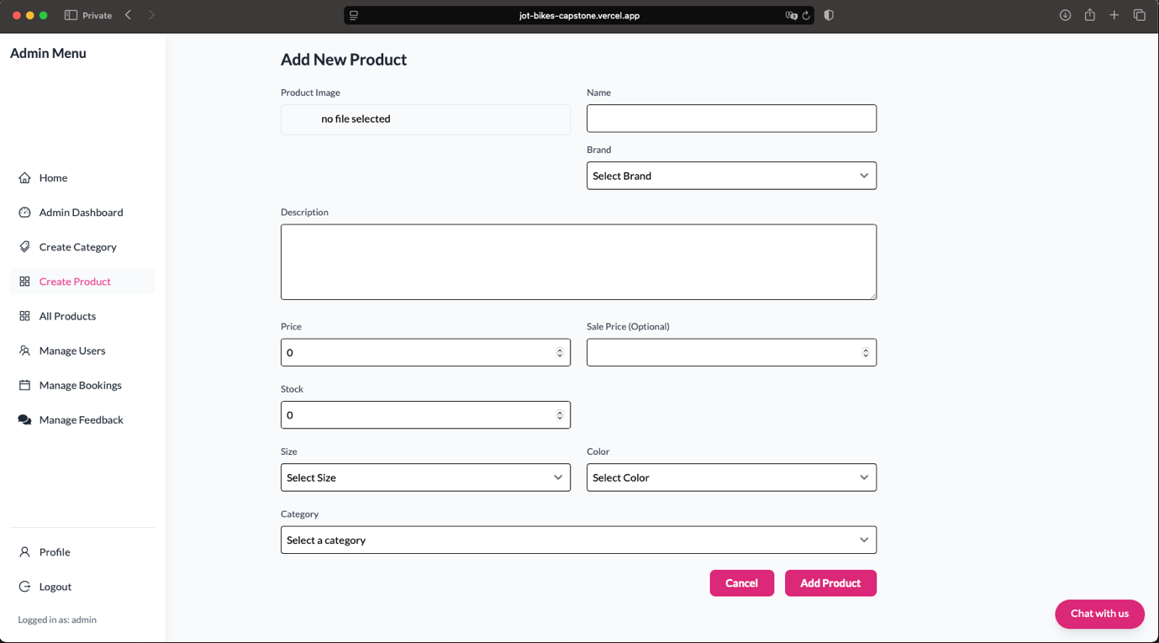

##### **Mechanisms for Updating Data:**

There is two ways to perform bike data updates:

1. Admin via the “All Product” page in the admin dashboard
2. Vendor via the “My Product” page in the vendor dashboard

Once the user clicks on the blue edit button, a form will appear which allow user to modify all the details of the product such as rental prices, stock quantity, product image and description. This feature provides quick and convenient access for vendors and admins to maintain accurate and up-to-date listings. Vendors are also able to adjust prices accordingly in response to demand or inflation and also able to mark bike as unavailable when it is schedule for maintenance. This feature ensures that JBMS are a friendly user interface to interact with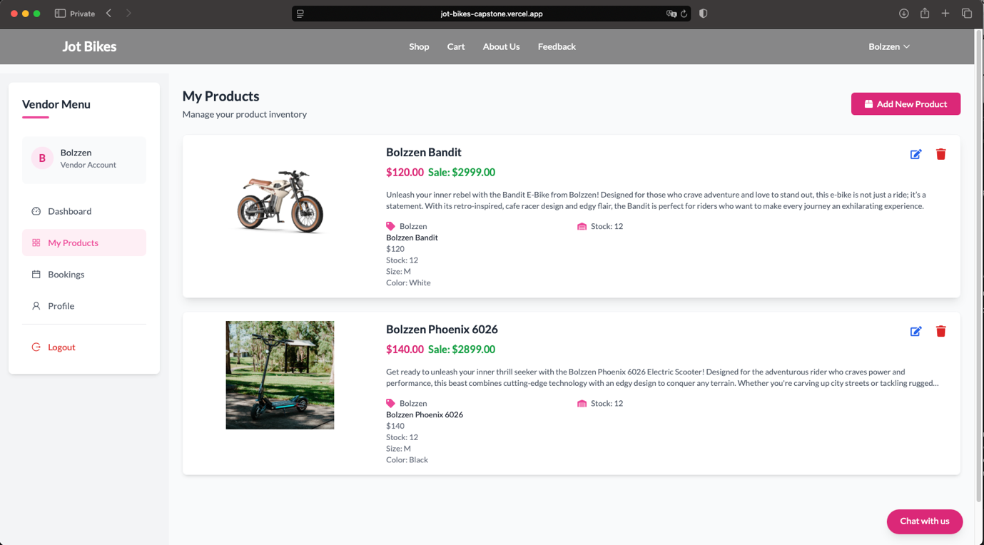.

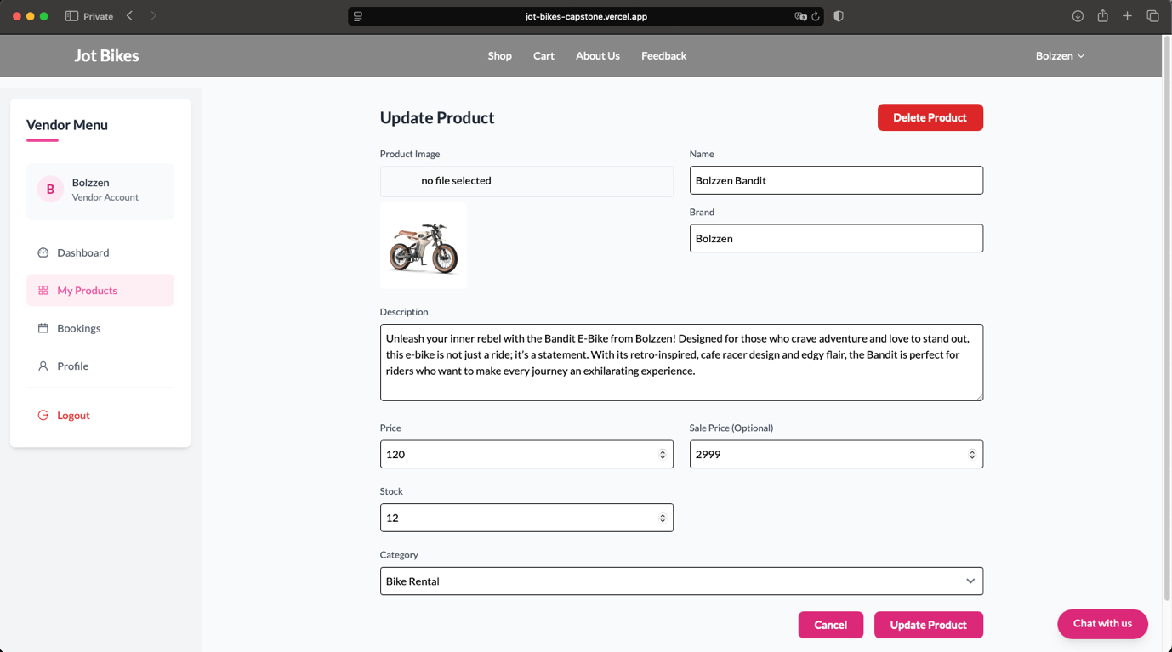

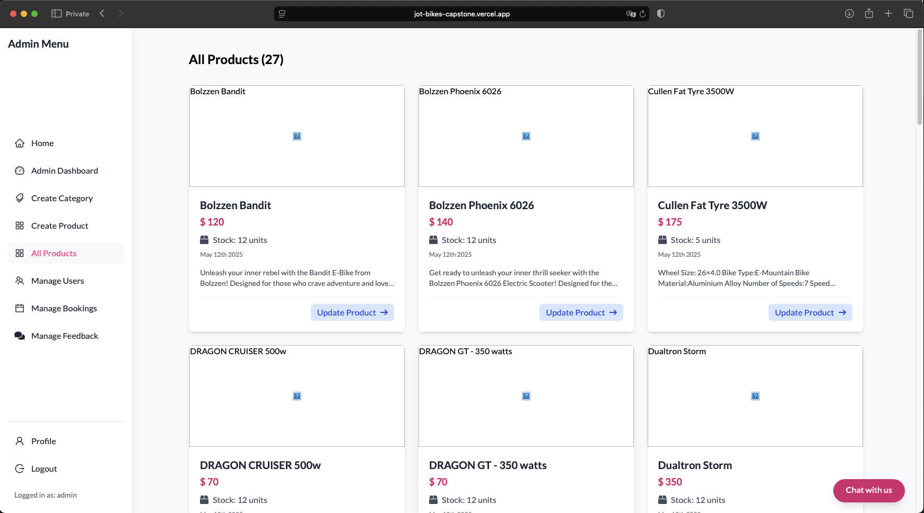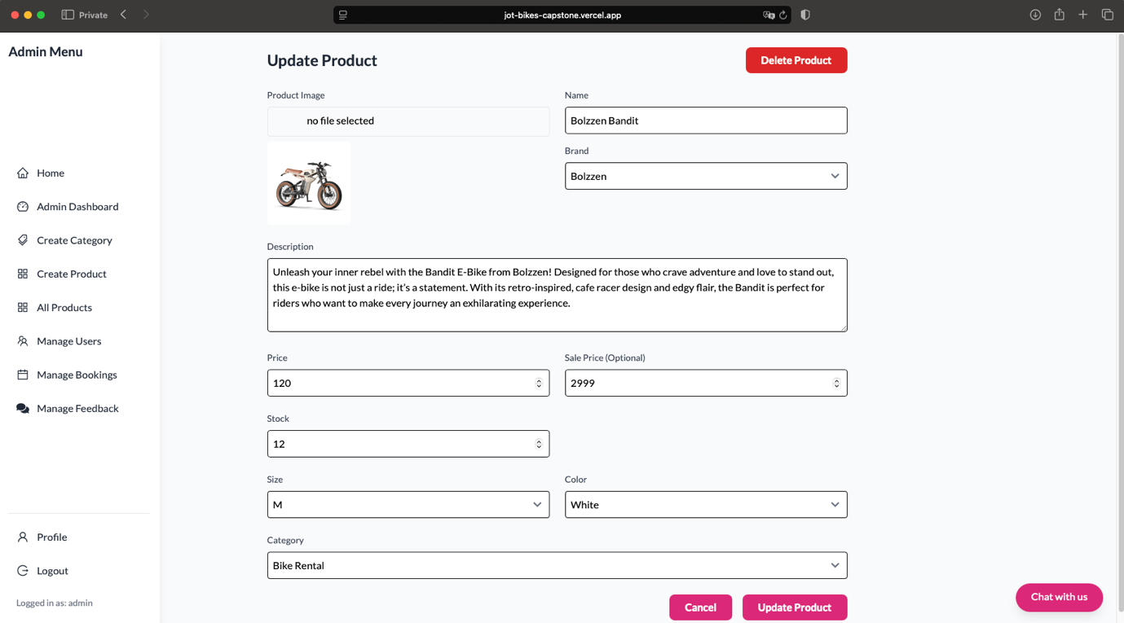

##### **Mechanisms for Deleting Data:**

Bike data deletion is integrated into the same interface used for updating products. To delete a bike listing, user must follow a three-step process:

1. Click on the “Edit” button on the product which was mentioned in the section before
2. Within the update form, click the clearly marked bright red “Delete Product” button
3. A confirmation prompt will appear asking “Are you sure you want to delete this product?”
4. Once selected “Ok” the bike data will be deleted on the MongoDB database and the changes will be reflected on the website

This extra layer of confirmation ensures that deletions are intentional. While the current approach is sufficient for operational use, a future enhancement could include a password confirmation step for added security and accountability.

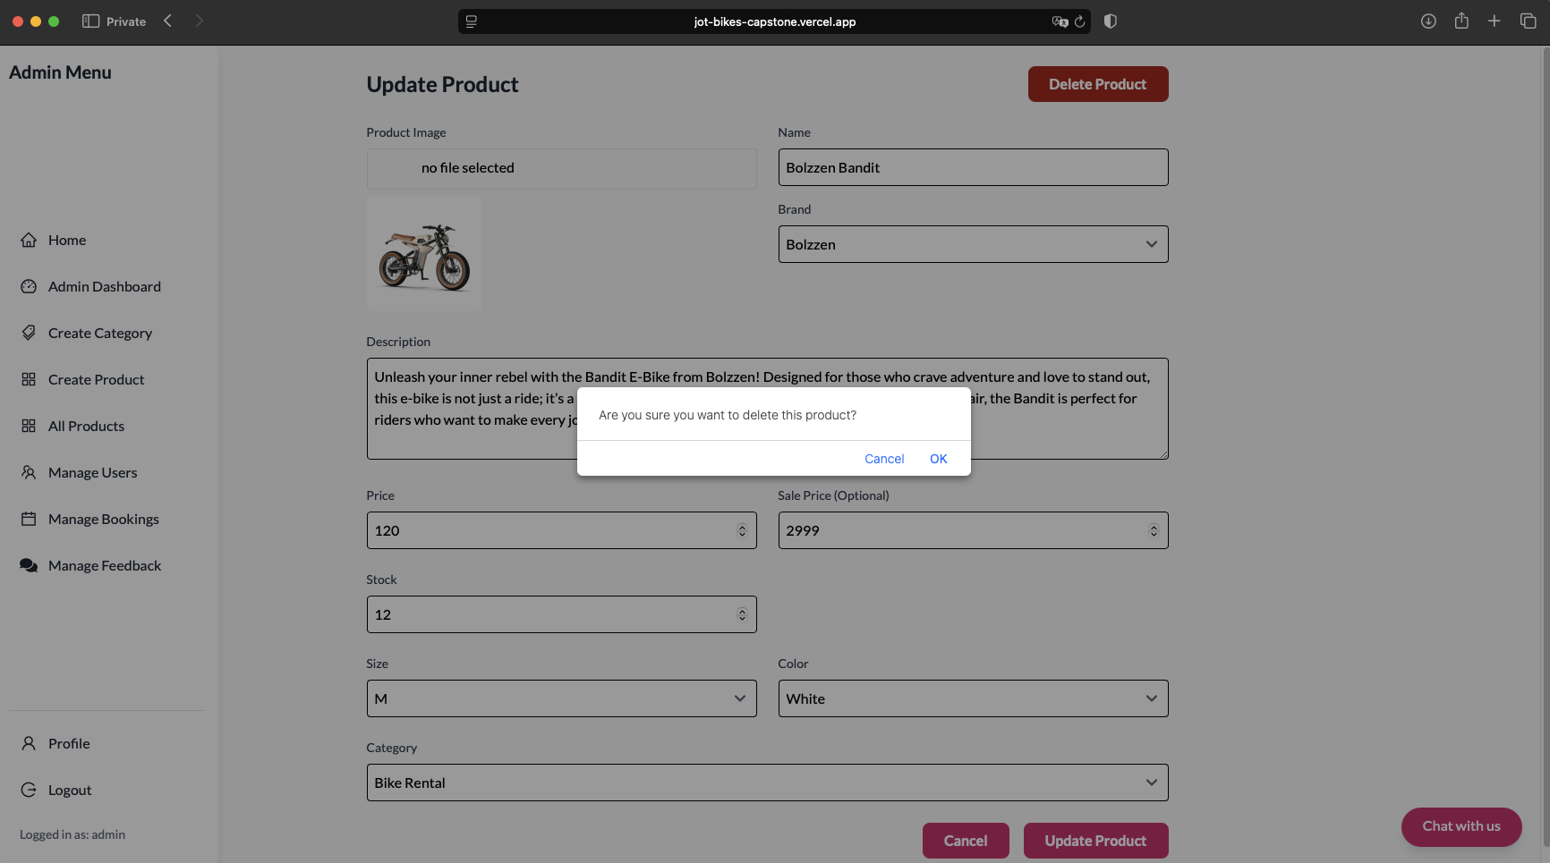

### Data Security and Encryption

In this era of modern technology, security and privacy is the utmost priority when it comes toward the design of JBMS. With sensitive user data such as personal information, booking history, and payment metadata that is being processed and stored. It is the utmost important that the team implement a multi-layered security architecture based on global practices such as OWASP, NIST and Australia Privacy Act. This security feature serve as a baseline protection suited for a small-scale implementation where budget constraints may prevent the adoption of enterprise-grade solution like CrowdStrike or other security platform.

**Security Measures Implemented:**

1. Password Hashing with Bcrypt

Password is a sensitive data that need to be stored in a secured condition, storing it in a plaintext is definitely a critical security risk. To mitigate this security risk, JBMS uses Bcrypt, a well-established algorithm that is designed to resist brute-force and rainbow table attacks. Bcrypt automatically salts the password and applies a computationally expensive hash function, which greatly increases security.

When a customer register / sign up, their password is hashed using Bcrypt before being stored in MongoDB Atlas. This will ensure that even if the database is compromised, attackers will not be able to recover user original password. Below are the code snippet on how the implementation will look like in the JBMS, on line 14 during login the plaintext password will be verified against the stored hash.

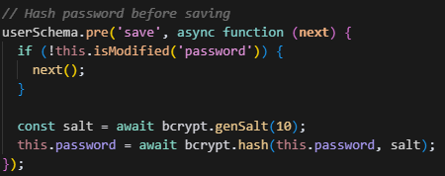

1. AES-256 Encryption for sensitive data at rest

JBMS leverages MongoDB Atlas, which provides a bult-in AES-256 encryption at rest. This encryption standard is highly recommended by NIST and is widely used for storing sensitive data. All data stored in JBMS are hosted on MongoDB Atlas which automatically encrypts data at rest, which is excellent as there will be less burden for the development team to do manual encryption in the application code.

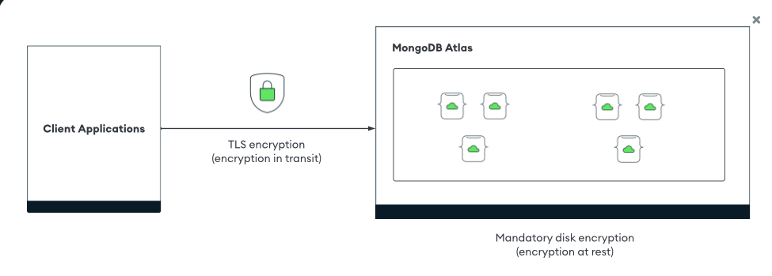

1. Email Anonymization for Analytics

JBMS is based in Australia, hence it must comply with Australia Privacy act. Personally Identifiable Information (PII) such as email addresses must be excluded from analytic and report. JBMS has implemented data masking to protect user identity while still allowing aggregated insights. Before analytics and logs are generated, email addresses are masked. So [K220685@student.kent.edu.au](mailto:K220685@student.kent.edu.au) becomes [K******@student.kent.edu.au](mailto:K******@student.kent.edu.au) , this will prevent email being identified. The code snippet is very short and easy to be implemented.

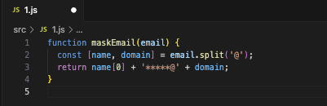

1. Role Based Access Control (RBAC)

Following the principle of least privilege, JBMS has adopted RBAC to ensure that user only see data relevant to their role (Admin, Vendor, and Customer).

How it is implemented in JBMS:

1. Admins can manage users, bookings, and products.
2. Vendor can only see and manage their own products and bookings.
3. User can manage their own profile, view bikes, and make bookings,

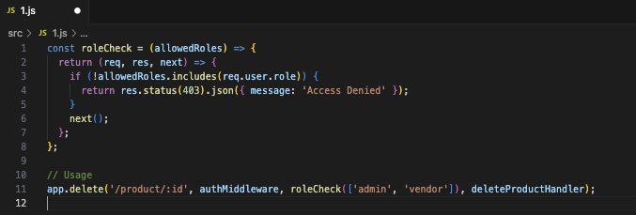

1. Secure Communications (HTTPS, Cookies, Token)

JBMS enforces secure transmission protocols, in order to protect login session, payment details and form submission. As data in transit is vulnerable to interception, it is crucial to have a secure communication.

Secure Communication Implementation:

1. HTTPS has been implemented across the entire frontend and backend (Vercel and Render deployments) <https://jot-bikes-capstone.vercel.app> It can be seen with the provided link it has HTTPS.
2. JWT (JSON Web Token) for session authentication, which is stored in HttpOnly cookies
3. Secure flag on cookies (Secure, SameSite=Strict, HttpOnly)
4. Consent & Data Control

Under the Australian Privacy Principles, user must be informed about how their data is collected and have control over it. Thus, it is important that the JBMS has implemented a privacy policy checkbox during registration. Admin dashboard will also have a feature where it can remove all personal and booking data related to the user when the user request for data deletion. The code snippet will look like this in the front end.

<label>

<input type="checkbox" required /> I have read and agree to the Privacy Policy

</label>

The JBMS system align with OWASP, NIST, and Australian legal standards that was applicable so the system will have security and privacy embedded at every level from login even to analytics. By using tools like Bcrypt, AES-256, RBAC, email anonymization, and secure HTTPS. JBMS has implemented a production-grade security posture which is suitable for real-world deployment. Advance security control can be applied selectively, based on the security requirements.

## **6. System Testing**

### **Testing Strategy**

Overview of Testing methods

* Unit Testing

Each functional component of the JBMS will be tested individually such as the login form, booking form, and product entry form. This will ensure that each component will perform as intended, which will allow development team to catch on any issue that occur during the development process.

* Integration Testing

After completing unit testing, the next priority would make sure that the different module of the system is communicating properly. For example, after user books a bike, the booking system must correctly update in both the user profile and the vendor’s booking dashboard.

* System Testing

Complete user journey was tested from start to end for all roles (Admin, Vendor, and Customer). This included registering an account, logging in, performing transactions, and managing products. Usability and expected workflows were manually validated in the deployed environment.

* User Acceptance Testing

This task has been allocated to the team member to test the website functionalities in general. Team member assumed the roles of vendors, users, and admins to simulate real-world use cases. This testing will confirm that the system met all the documented requirements and was intuitive to use.

Tools and Environment

The tools and environment have been carefully selected for testing of JBMS system purpose, this will ensure that the JBMS system will be evaluated thoroughly across a variety of environment and devices. Testing was conducted using popular web browser, including Google Chrome and Safari, on both mobile phones and desktop/laptop system running Windows and macOS. This will help to confirm that the platform remained responsive and functionally consistent across different screen sizes and operating system.

The backend database was hosted on MongoDB Atlas, which provided a cloud-based environment for observing real-time changes to data collections such as users, products, bookings, and feedback. During testing, manual validation was performed by checking that data inserted or update through the user interface was correctly reflected in the database. Any miscommunication at this stage can be thoroughly troubleshoot before moving on and integrating the whole website.

The frontend of the JBMS system was deployed on Vercel, which is a cloud hosting platform which is well-suited for React applications, which allow the team to perform live system testing in a realistic production-like environment. This allow the website to stay active 24/7 without having any downtime which is important for tester to simulate end-user behaviour and workflows across the full application stack.

The most important tool for this test cases is all the source code will be managed and version controlled using GitHub, this is to ensure that any changes made during the testing phase were tracked, reviewed, and recoverable. This setup also supported team collaboration and allowed quick iteration when bugs or UI issue were discovered.

### **Test Results**

Below are the list of Unit testing that need to be conducted on the JBMS System

|  |  |
| --- | --- |
| Test | Objective |
| 1 | Test user registration |
| 2 | Test user login |
| 3 | Test login with invalid credentials |
| 4 | Vendor adds a new product |
| 5 | Admin deletes a user |
| 6 | Logout successfully |

Below table will show the expected result vs actual result which will be followed by screenshot of each testing being conducted.

|  |  |  |  |  |
| --- | --- | --- | --- | --- |
| Test | Objective | Expected Result | Actual Result | Status |
| 1 | Test user registration | User account is created | Account created successfully | Test pass |
| 2 | Test user login | User is logged in | Login successfully | Test pass |
| 3 | Test login with invalid credentials | User is denied access | Error message displayed | Test pass |
| 4 | Vendor adds a new product | Product is listed to customer | Products appear in listing | Test pass |
| 5 | Admin deletes a user | User is removed from DB | User is no longer listed | Test pass |
| 6 | Logout successfully | User successfully logout | Logout successful is displayed | Test pass |

Test 1 User Registration

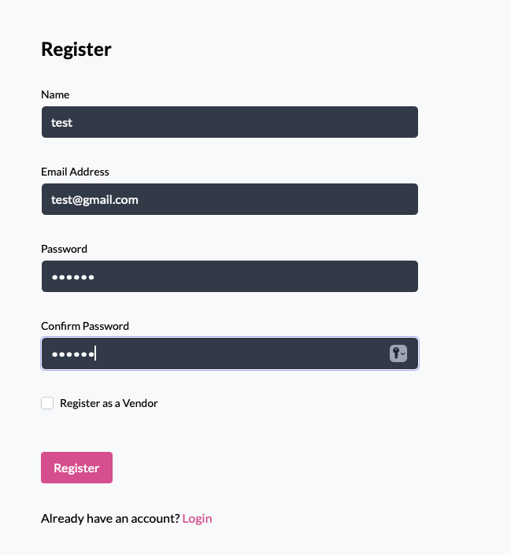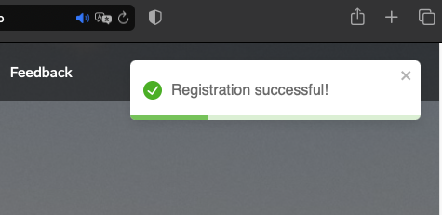

Test 2 User Login

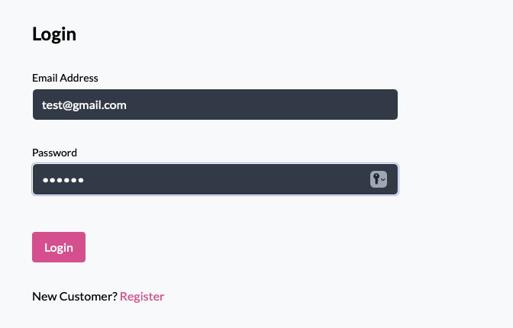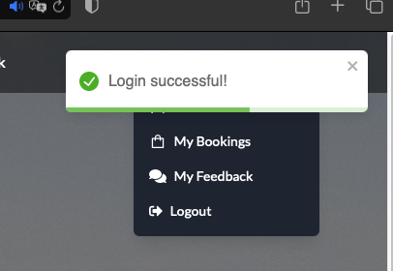

Test 3 Login with Invalid credentials

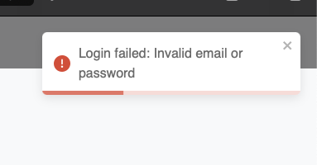

Test 4 Vendor adds a new product

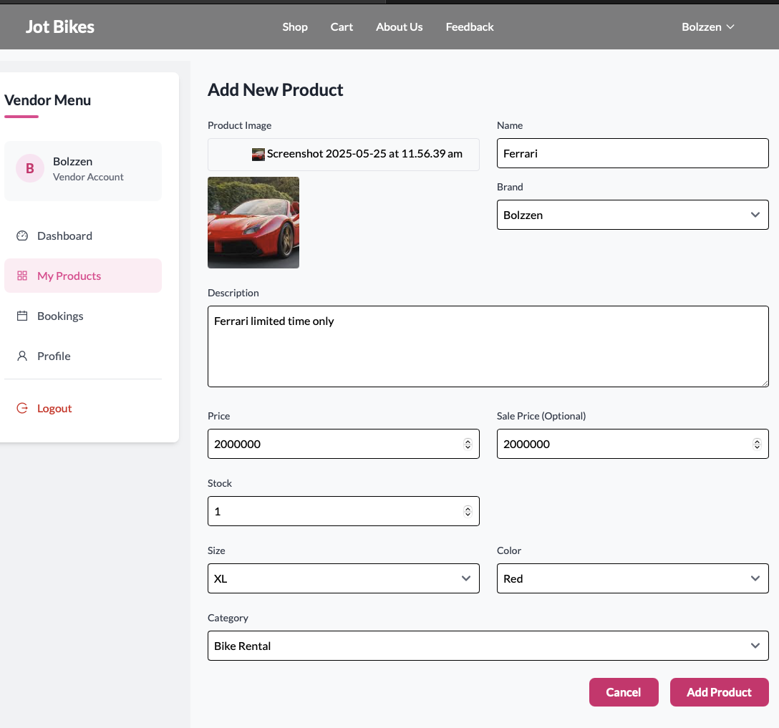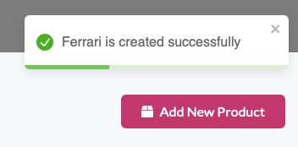

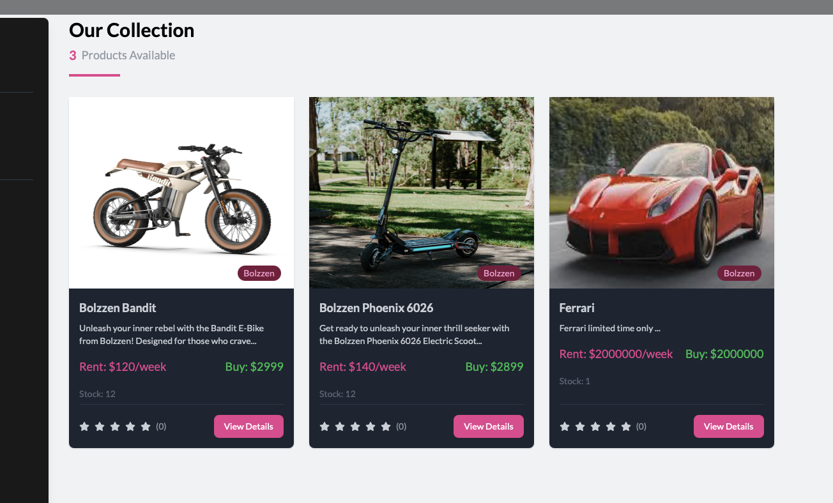

Test 5 Admin Delete user

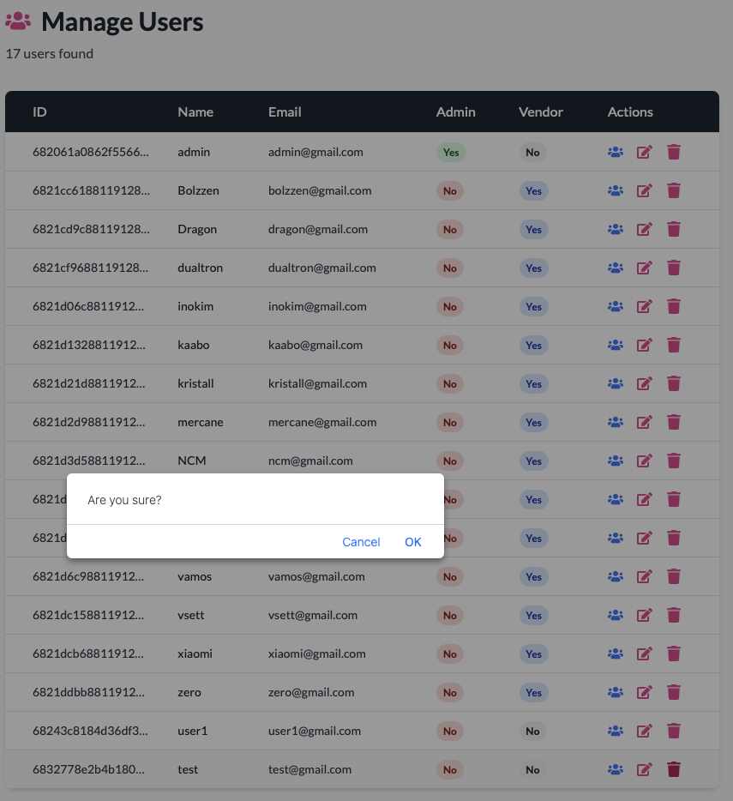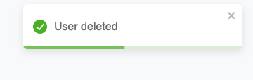

Test 6 Logout Successfully



The screenshot has shown that all the unit test cases passed. The next phase of testing is the system testing as shown in below table.

|  |  |
| --- | --- |
| Test | Objective |
| 1 | Full booking flow |
| 2 | Vendors update product price |
| 3 | User giving feedback |
| 4 | Admin views feedback |
| 5 | User edits their profile |
| 6 | Admin cancel bookings |

Below table will show the expected result vs actual result which will be followed by screenshot of each testing being conducted.

|  |  |  |  |  |
| --- | --- | --- | --- | --- |
| Test | Objective | Expected Result | Actual Result | Status |
| 1 | Full Booking flow | Booking record created and confirmed | Booking confirmed | Test pass |
| 2 | Vendors update product price | Price changes are reflected | Price is updated in both view | Test pass |
| 3 | User giving feedback | Feedback will be received | Admin able to view feedback | Test pass |
| 4 | Admin views feedback | Admin can view and respond to feedback | Respond send and case can be closed | Test pass |
| 5 | User edit their profile | User are able to change their password | User successfully change their password | Test pass |
| 6 | Admin cancel bookings | Booking status is updated to “cancelled” | Status is updated correctly | Test pass |

Test 1 Full Booking Flow

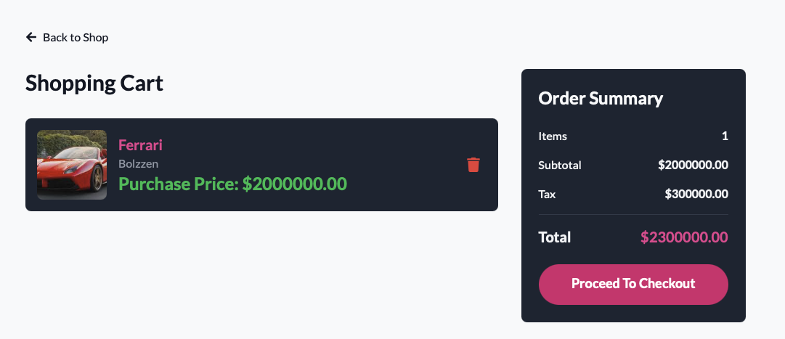

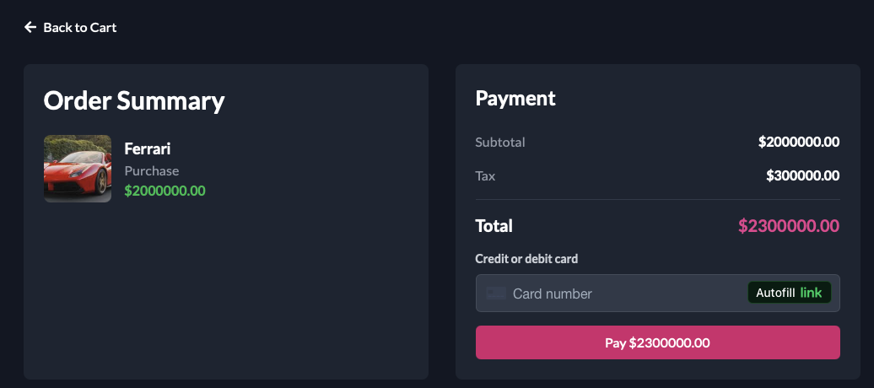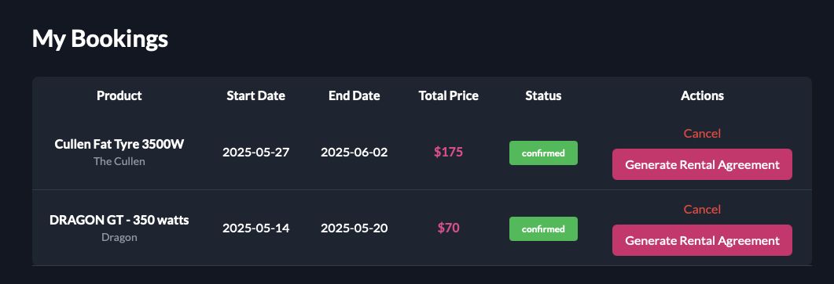

Test 2 Vendor update product price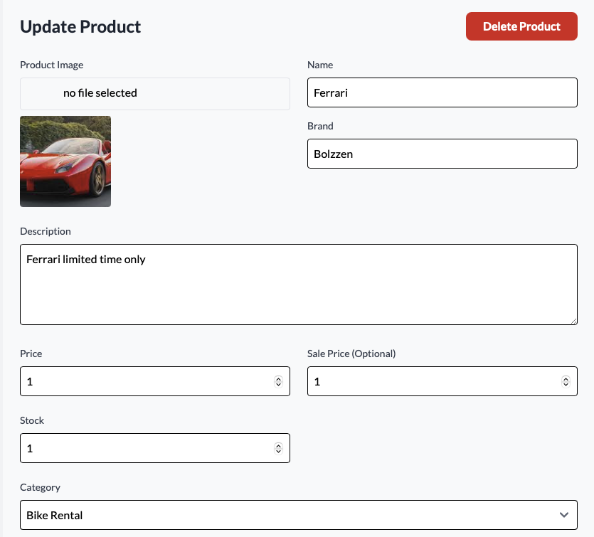

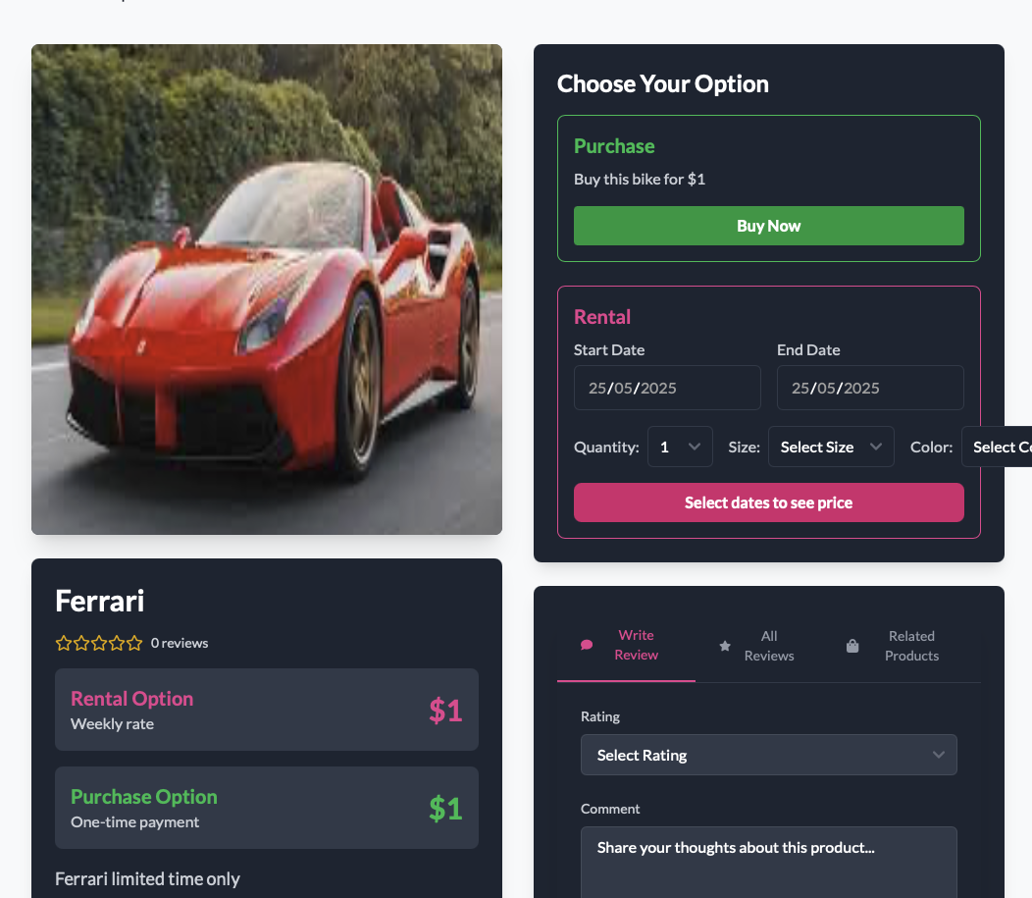

Test 3 User giving feedback

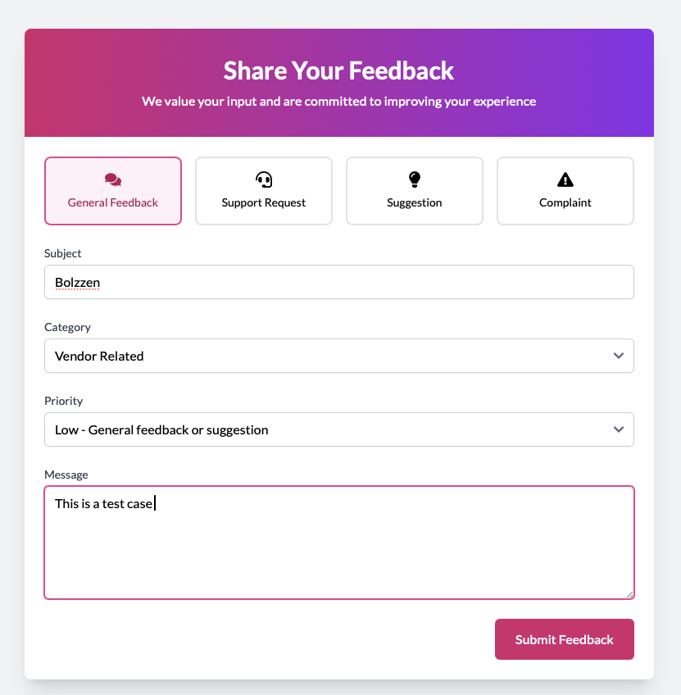

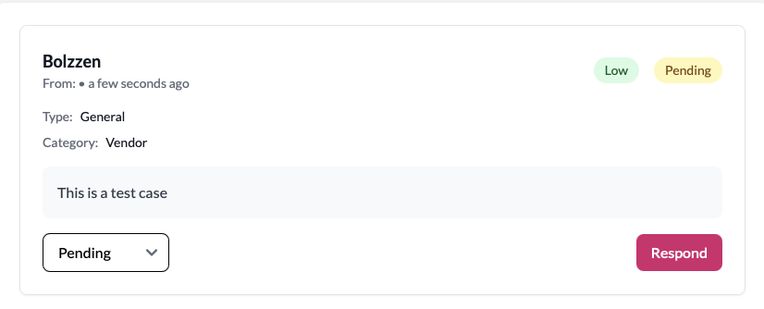

Test 4 Admin view feedback 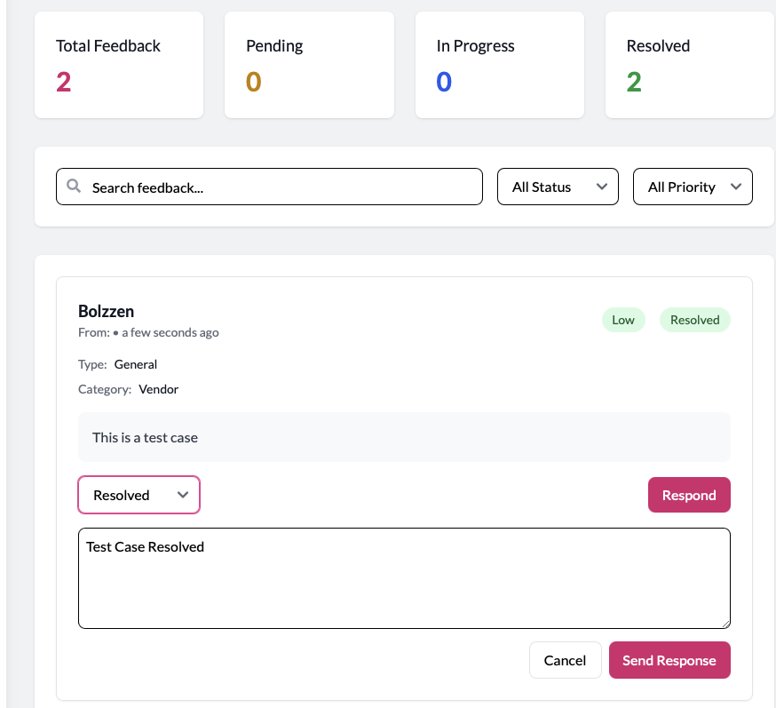

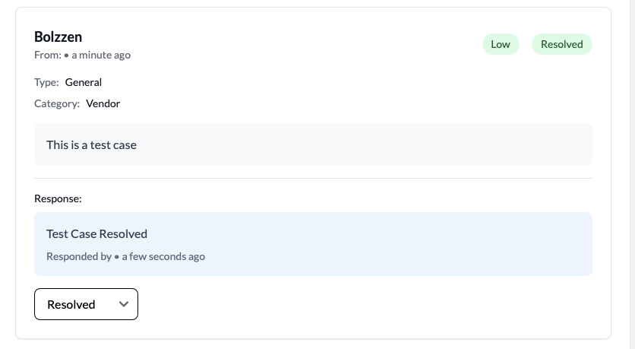

Test 5 user edit their profile

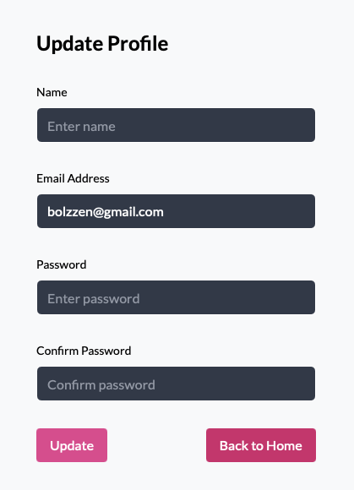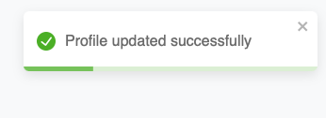

Test 6 admin cancel bookings

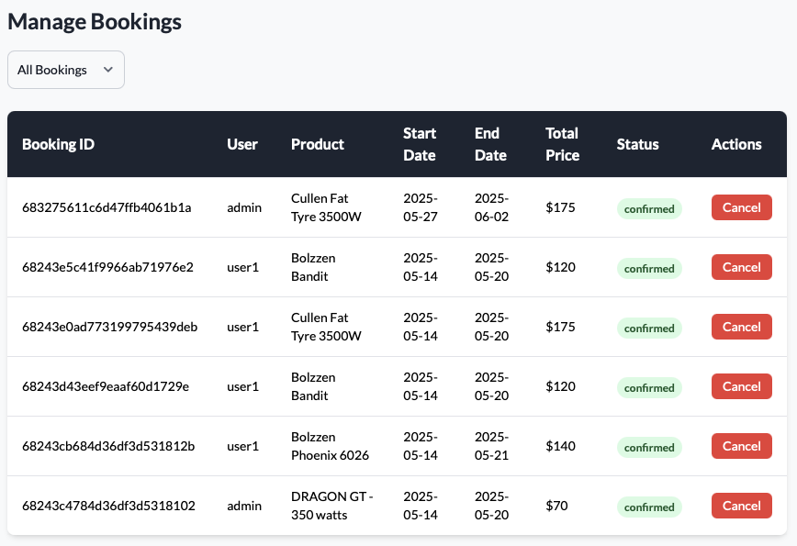

## **7. Documentation**

### **System Documentation**

#### **Customer manuals**

* + - 1. Introduction

Welcome to the Jot Bikes Management System (JBMS) Customer manual. This guide is designed for customer who wish to book electric bikes through our online platform. By following this manual, you will learn how to:

* Create and verify your JBMS account
* Log in and navigate the website
* Search for available bikes and review their details
* Complete a booking, including payment
* View and cancel your bookings
* Manage your personal profile settings

JBMS make renting an e-bike simple and convenient this manual is designed to walk you through every step, whether you are on desktop or mobile

* + - 1. System Requirements

Before you begin, please ensure that your device and browser meet the following requirements:

Browser – Google Chrome (v80 or higher), Safari (IOS 14+/macOS 11+), Firefox (v75 or higher)

Devices – Desktop or laptop (Windows 10+, macOS 11+), tablet or smartphone (IOS, Android)

Settings – JavaScript enabled, Cookies enabled, Stable internet connection (>5 Mbps)

* + - 1. Getting Started

To access the JBMS, please launch your browser and navigate to:

<https://jot-bikes-capstone.vercel.app>

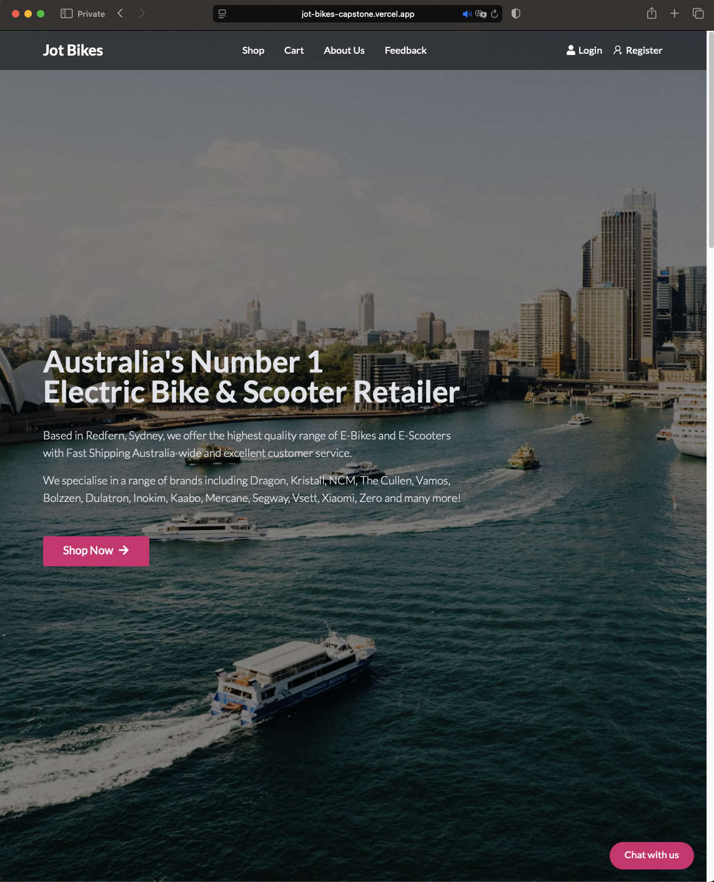

Create Your Account

Click Register located at the top right of the navigation

Complete the form with:

- Full Name

- Email Address

- Password

- Confirm Password

- Check “I agree to the Privacy Policy”

Click Register

Once Registered you will be taken to the login page

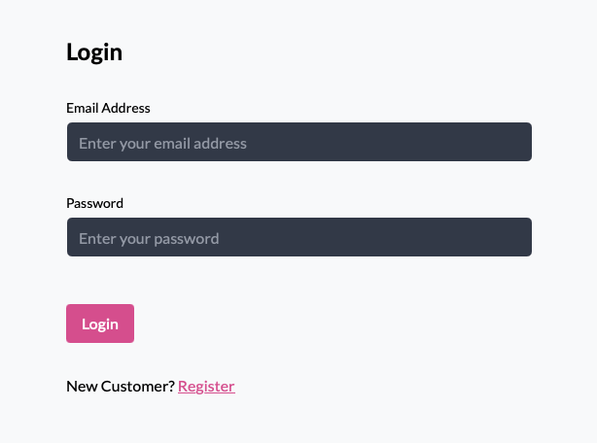

* + - 1. Logging In

From the Homepage, click Login

Enter your Email and Password

Click Login

Upon successful login, you will be taken to the customer Homepage

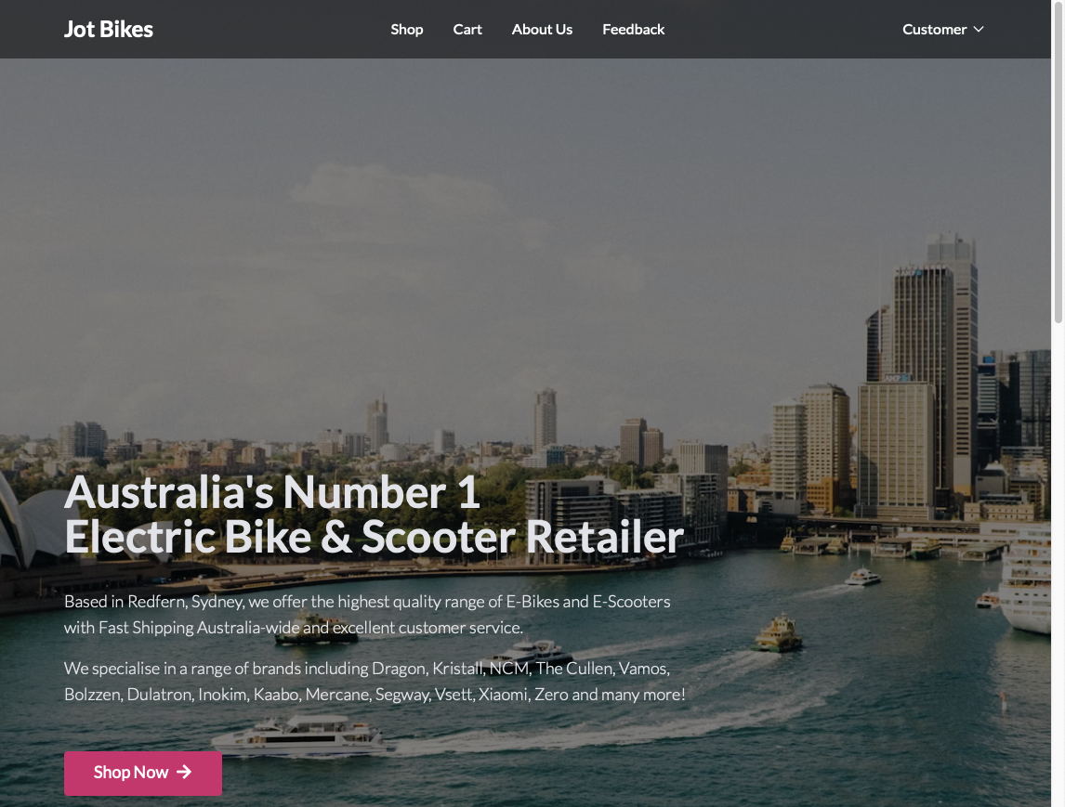

* + - 1. Browsing Bikes

Navigate to Shop from the main menu

Use the filters to narrow by:

* Categories
* Brand
* Price

Click on any bike thumbnail to view detailed information

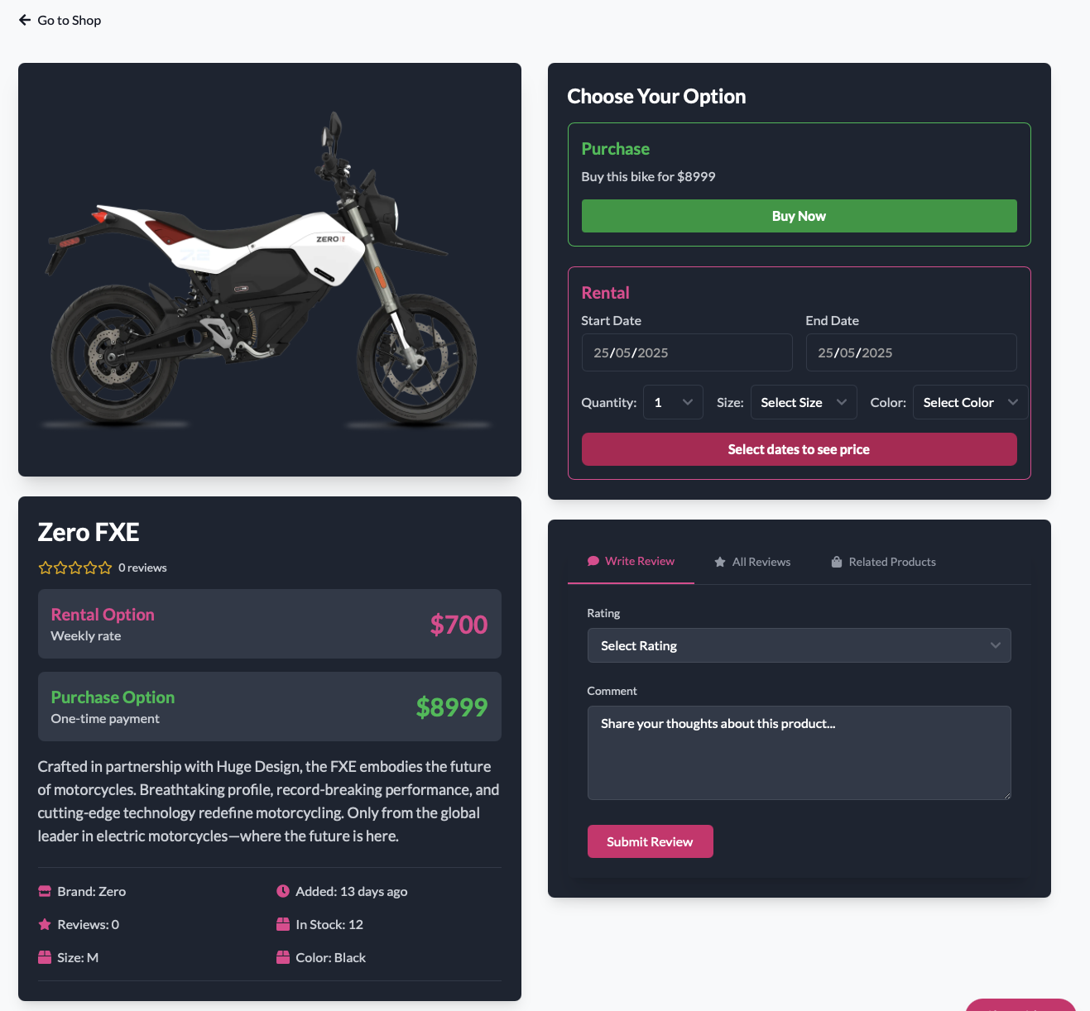

* + - 1. Making a Booking

On the bike’s detail page, select your Start Date and End Date

Enter the quantity of bikes you need

Click Book Now

It will take you to your cart, click proceed to checkout

Choose a Payment Method and enter your payment details

Click Confirm Booking

You will see a Booking Confirmation screen and receive an email receipt

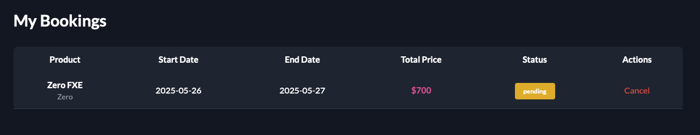

* + - 1. Managing Your Bookings

Go to My Bookings in your Dashboard

View all the booking

To cancel, click Cancel Booking and confirm

A cancellation email will be sent, and any eligible refund processed per policy

* + - 1. Profile Management

Click profile in the top-right menu

Update your Personal Details (Name and email address)

To change your password, click Change Password, enter your current and new passwords, and update.

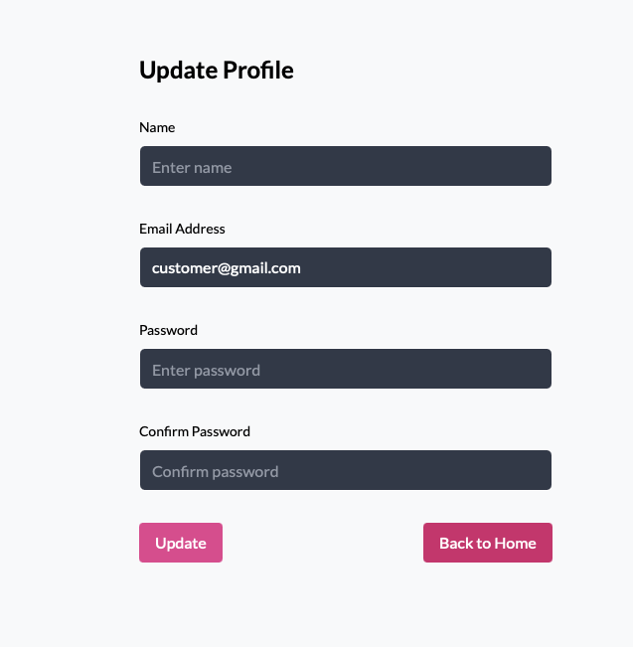

* + - 1. Troubleshooting & FAQs

|  |  |
| --- | --- |
| Issue | Solution |
| Didn’t receive verification email? | Check spam folder; click resend verification on Sign Up page. |
| Forgot your password? | Click Forgot Password on log in page; enter your email for a reset link. |
| Booking form won’t submit | Ensure all required fields are filled; check date range and quantity are valid. |
| Payment declined | Verify card details, billing address, and funds; try another payment method. |
| “Access Denied” on certain pages | Log out and log back in; ensure you are using the correct account. |
| Bike not listed for selected dates | Adjust date filters; if still unavailable, choose different dates or contact support. |

* + - 1. Support

If you need further assistance, please reach out:

* Email: [info@jotbikes.com](mailto:info@jotbikes.com)
* Phone: +1 234 567 8900 (Mon-Fri, 9 AM – 6 PM AEST), (Sat-Sun, 10 AM – 4 PM)
* Chat Bot: Click the chat icon at the bottom-right corner (available 24/7)
* Help Canter: <https://jot-bikes-capstone.vercel.app/feedback>

Our support team responds within 1 business day. For urgent on-trip issues, please call our emergency hotline.

##### **Vendor User Manual**

1. Introduction

Welcome to the Jot Bikes Management System (JBMS) Vendor manual. This guide is designed for vendor who wish to list, manage, and monitor electric bike and view bookings through their dedicated dashboard. By following this manual, you will learn how to:

* Create and verify your JBMS account
* Log in and navigate the website and Vendor Dashboard
* Add, edit, and delete bike listings
* View and filter your bookings
* Manage your vendor profile settings

JBMS make renting an e-bike simple and convenient this manual is designed to walk you through every step, whether you are on desktop or mobile

1. System Requirements

Before you begin, please ensure that your device and browser meet the following requirements:

Browser – Google Chrome (v80 or higher), Safari (IOS 14+/macOS 11+), Firefox (v75 or higher)

Devices – Desktop or laptop (Windows 10+, macOS 11+), tablet or smartphone (IOS, Android)

Settings – JavaScript enabled, Cookies enabled, Stable internet connection (>5 Mbps)

1. Getting Started

To access the JBMS, please launch your browser and navigate to:

<https://jot-bikes-capstone.vercel.app>



Create Your Account

Click Register located at the top right of the navigation

Complete the form with:

- Full Name

- Email Address

- Password

- Confirm Password

- Check “I agree to the Privacy Policy”

- Check “Sign up as a vendor”

Click Register

Once Registered you will be taken to the login page



1. Logging In

From the Homepage, click Login

Enter your Email and Password

Click Login

Upon successful login, you will be taken to the vendor dashboard

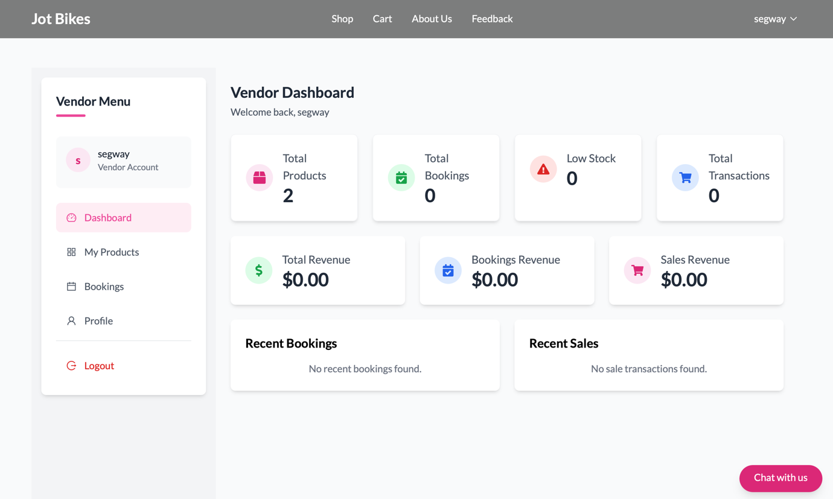

1. Adding a New Bikes
   * + 1. In your vendor dashboard click My Product, then click on Add New Product
       2. Fill in the form fields
       3. Click Add Product
       4. Verify your bike appears under My Products and on the public Shop page

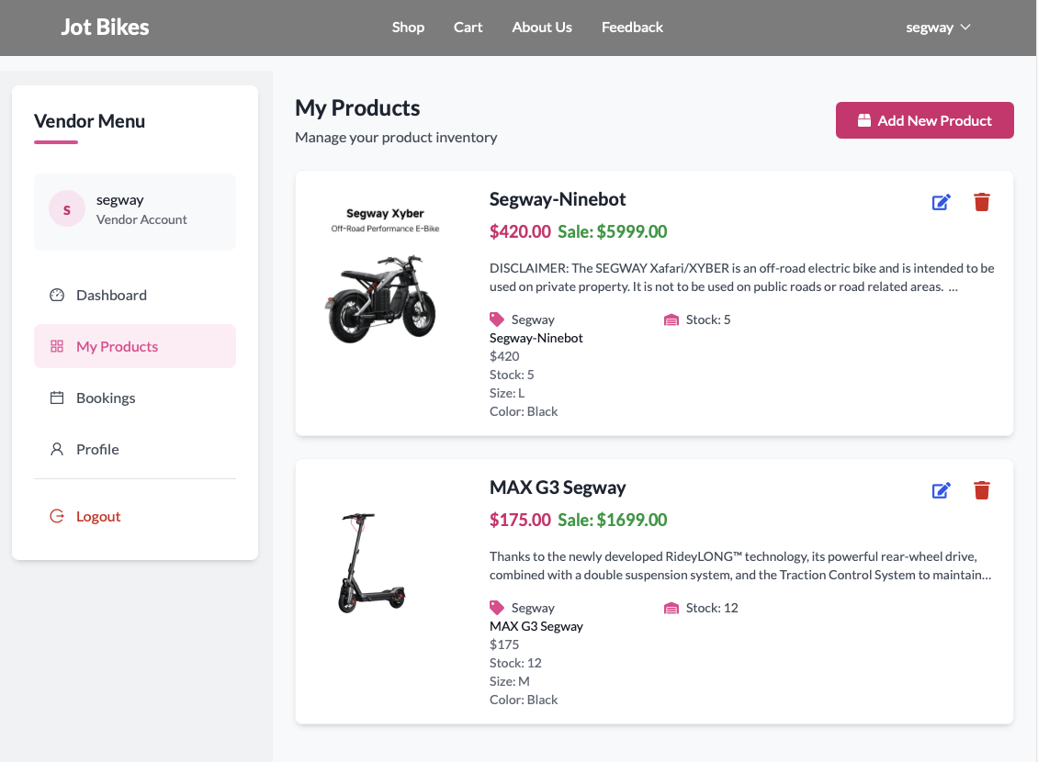

1. Editing an Existing Bike
   * + 1. In My product, click Edit on the target bike
       2. Update any fields (price, stock count, images, availability)
       3. Click Update Product
       4. Verify your bike is updated under My Products and on the public Shop page
2. Deleting a Bike
   * + 1. In My Product, click Delete on the target bike
       2. Confirm the prompt “Are you sure you want to delete this product?”
       3. The bike will be removed from your listings and the public site.
3. Viewing Bookings
   * + 1. Click Bookings in the Vendor Dashboard
       2. Use filter to sort by Booking confirmed or cancelled
       3. Click on the booking for full details
4. Troubleshooting & FAQs

|  |  |
| --- | --- |
| Issue | Solution |
| Cannot sign up as vendor | Ensure all fields and document are uploaded; re-submit the form |
| Approval email not received | Check spam/junk folder; contact admin if pending over 24 hours |
| New product not showing | Verify mandatory fields are complete; refresh dashboard after a few minutes |
| Edit form won’t save | Check validation errors |
| Delete button greyed out | Use desktop browser |
| No bookings displayed | Adjust filter |

1. Support

If you need further assistance, please reach out:

* Email: [info@jotbikes.com](mailto:info@jotbikes.com)
* Phone: +1 234 567 8900 (Mon-Fri, 9 AM – 6 PM AEST), (Sat-Sun, 10 AM – 4 PM)
* Chat Bot: Click the chat icon at the bottom-right corner (available 24/7)
* Help Canter: <https://jot-bikes-capstone.vercel.app/feedback>

Our support team responds within 1 business day. For urgent vendor issues, please call our emergency hotline.

##### **Admin User Manual**

1. Introduction

Welcome to the Jot Bikes Management System (JBMS) Admin manual. This guide is designed for administrator who must manage users, vendors, products, and bookings. By following this manual, you will learn how to:

* Log in, navigate the website and Admin Dashboard
* Oversee customer and vendor accounts
* Add, edit, and delete bike listings
* View and filter all bookings
* Review user feedback and system reports

1. System Requirements

To access administer platform ensure:

Browser – Google Chrome (v80 or higher), Safari (IOS 14+/macOS 11+), Firefox (v75 or higher)

Devices – Desktop or laptop (Windows 10+, macOS 11+), tablet or smartphone (IOS, Android)

Settings – JavaScript enabled, Cookies enabled, Stable internet connection (>5 Mbps)

1. Getting Started

Admin account setup

* Admin account will be provisioned by the system owner
* You will receive an email with your Admin credentials and login URL

1. Logging In

From the Homepage, click Login

Enter your Email and Password

Click Login

Upon successful login, you will be taken to the Admin dashboard

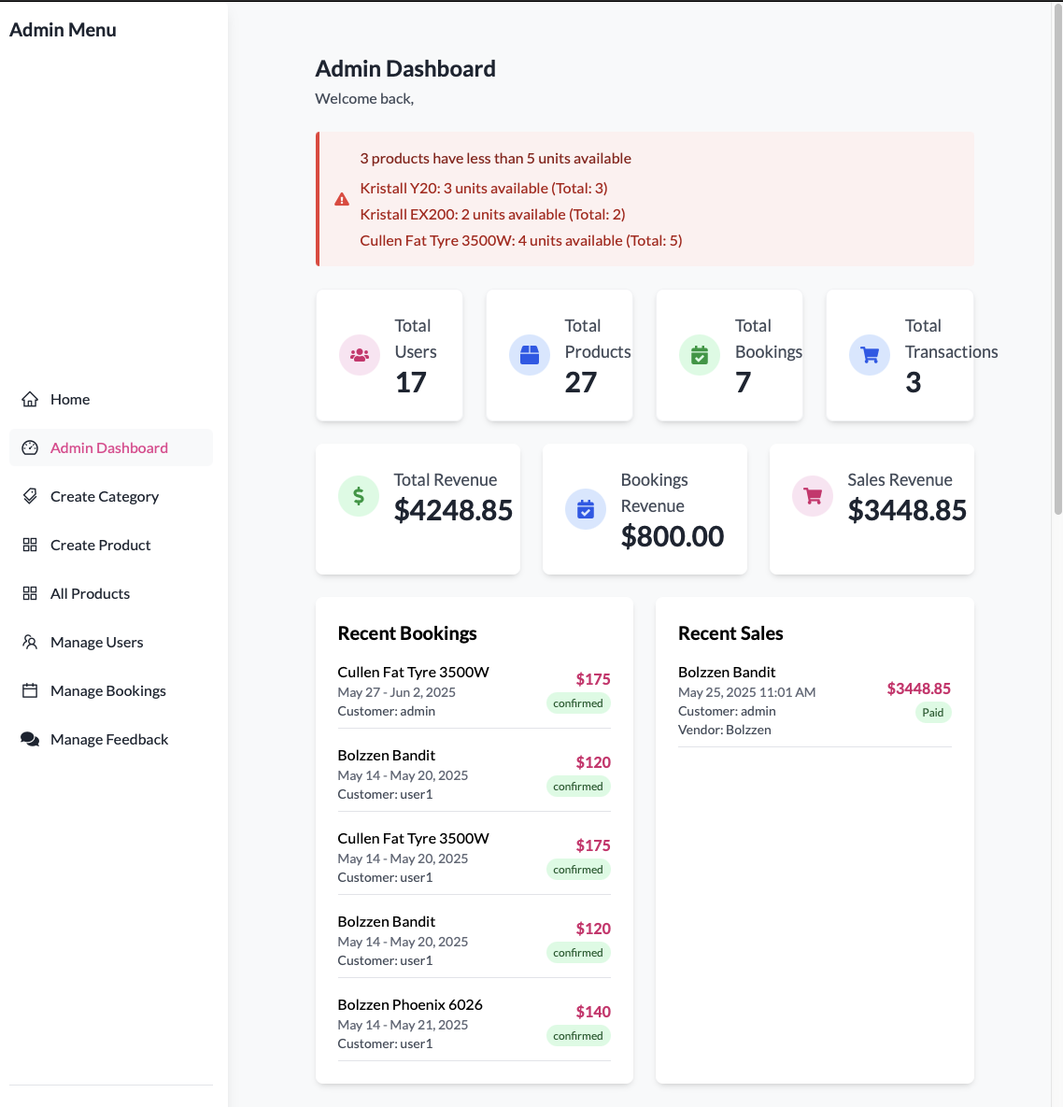

1. Dashboard Overview

Your dashboard shows:

* System Metrics: Total users, product, bookings and transaction
* Quick Actions: Buttons to create product, manage bookings, and manage feedback
* Recent Activity: Recent bookings, Recent Sales, Inventory Analysis of fast moving products, slow moving product and non-moving product.

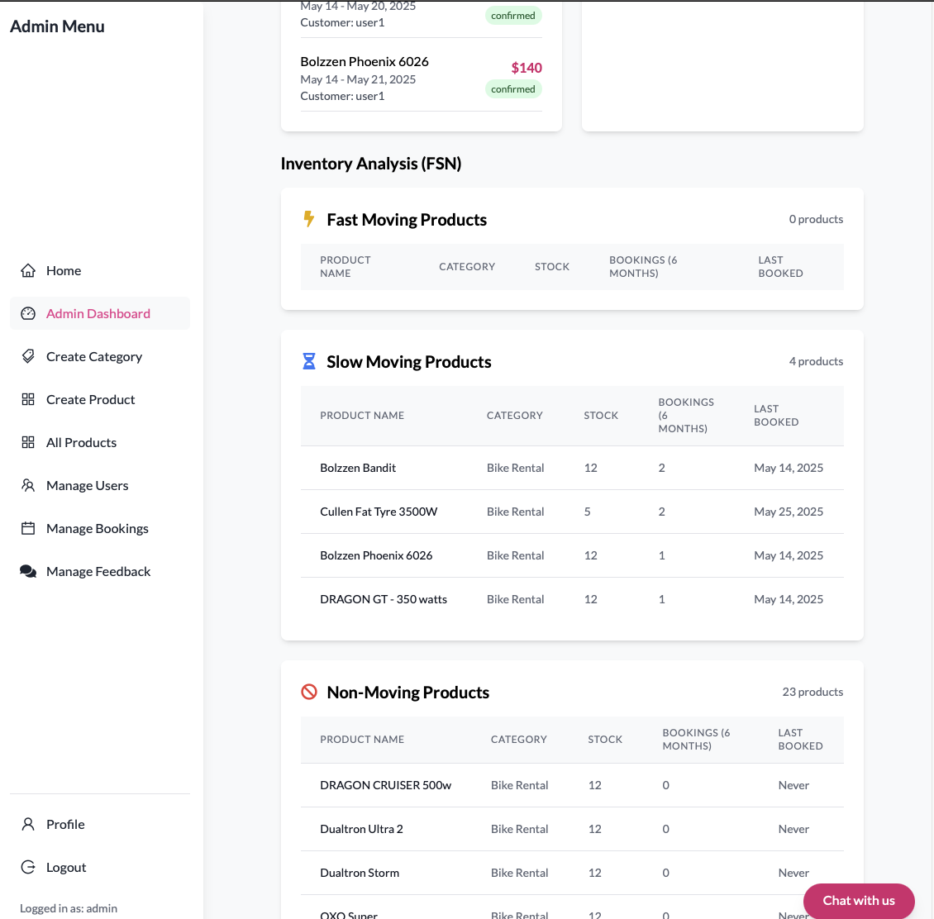

1. User Management
   * + 1. Go to Manage Users, which is in the Admin menu
       2. View all customers and vendors (name, email)
       3. Click edit to update user details or delete and remove the account
       4. Changes are audited in the system logs

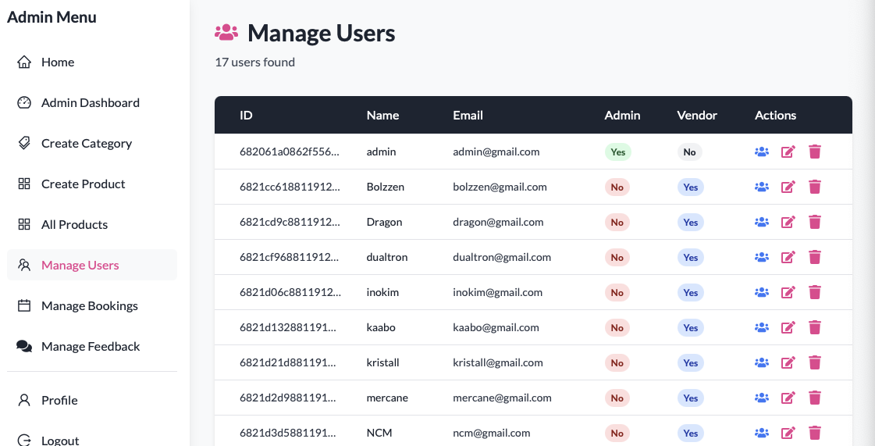

1. Product Management
   * + 1. Click All Product
       2. Update any product that need to be updated
       3. All changes reflect immediately in the public Shop page
2. Feedback Management
   * + 1. Click Manage Feedback
       2. Admins can search feedback and filter it by status and priority
       3. Resolve the feedback by providing appropriate response

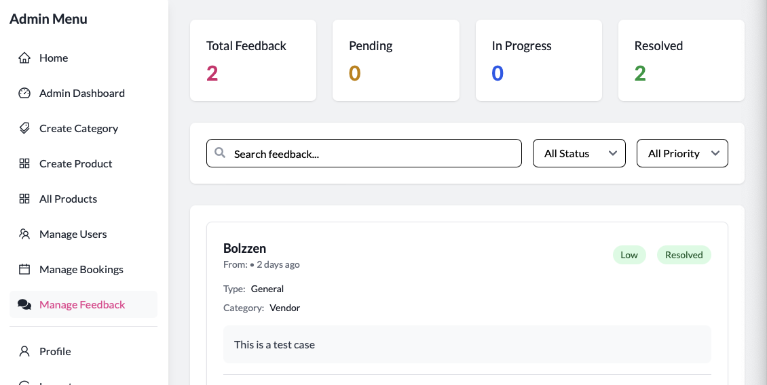

1. Troubleshooting & FAQs

|  |  |
| --- | --- |
| Issue | Solution |
| Cannot access Admin Dashboard | Ensure you are using the admin-login URL and correct credentials |
| Vendor approval button missing | Refresh the page |
| Product not updating | Check that all required fields are valid |
| Booking status won’t update | Refresh the page |
| Feedback not visible | Filter feedback by status |
| Role assignment errors | Use edit user to assign or change role |

1. Support

If you need further assistance, please reach out:

* Email: [info@jotbikes.com](mailto:info@jotbikes.com)
* Phone: +1 234 567 8900 (Mon-Fri, 9 AM – 6 PM AEST), (Sat-Sun, 10 AM – 4 PM)
* Chat Bot: Click the chat icon at the bottom-right corner (available 24/7)
* Help Canter: <https://jot-bikes-capstone.vercel.app/feedback>

### **Code Documentation**

#### **A. Explanation of Code Structure**

a1. Frontend Structure

- Components are orgnaized in feature-based directories.

- Redux integration for state management

- Protected routes using role-based access control

frontend/

├── src/

│ ├── components/ # Reusable UI components

│ ├── pages/ # Page components

│ ├── redux/ # State management

│ │ ├── api/ # API slices

│ │ ├── features/ # Redux features

│ │ └── store.js # Store configuration

│ ├── utils/ # Utility functions

│ ├── assets/ # Static assets

│ ├── screens/ # Screen components

│ ├── App.jsx # Main application component

│ └── main.jsx # Application entry point

a2. Backend Structure

- RESTful API endpoints

- Middleware-based authentication

- Controller-based business logic

- Model-based data structure

backend/

├── config/ # Configuration files

├── controllers/ # Route controllers

├── models/ # Database models

├── routes/ # API routes

├── middlewares/ # Custom middlewares

├── utils/ # Utility functions

├── scripts/ # Utility scripts

├── uploads/ # File upload directory

└── index.js # Application entry point

#### **B. Comments and Annotations in the Code**

**B1. Code Comments:**

- **File Headers**: Description of the file purpose and functionality

- **Function Documentation:** Purpose, parameters, and return values

- **Complex Logic:** Explanation of complex algorithms or business logic

- **TODO Comments:** Future improvements or fixes

**B2. Type Annotations**

/**

* @typedef {Object} User

* @property {string} username - User's username

* @property {string} email - User's email address

* @property {boolean} isAdmin - Admin status

* @property {boolean} isVendor - Vendor status

*/

API Documentation

/**

* @api {post} /api/users/login User Login

* @apiName LoginUser

* @apiGroup User

* @apiParam {String} email User's email

* @apiParam {String} password User's password

* @apiSuccess {String} token JWT token

*/

Configuration Documentation

// CORS configuration

app.use(

cors({

origin: [

'http://localhost:5173',

'https://jot-bikes.vercel.app',

// ... other origins

],

credentials: true,

})

);

**B3. Documentation Standards**

A. Code Style

- Consistent indentation

- Clear variable naming

- Modular code organization

- DRY (Don't Repeat Yourself) principle

B. Comment Guidelines

- Use JSDoc for function documentation

- Explain complex logic

- Document API endpoints

C. File Organization

- Logical grouping of related files

- Clear directory structure

- Consistent file naming

- Separation of concerns

D. Version Control

- Meaningful commit messages

- Branch naming conventions

- Pull request documentation

- Change log maintenance

##### **Admin Dashboard Module**

##### **Dashboard Module**

Purpose: The Dashboard Module serves as the central control center for administrators, providing real-time insights into system performance, user activities, and business metrics.

Key Features:

A. Statistical Overview

* Total Users Count
* Total Products Count
* Total Bookings Count
* Total Transactions Count

UI View of Statistical Overview that shows Total Users, Total Products, Total Bookings, and Total Transactions.

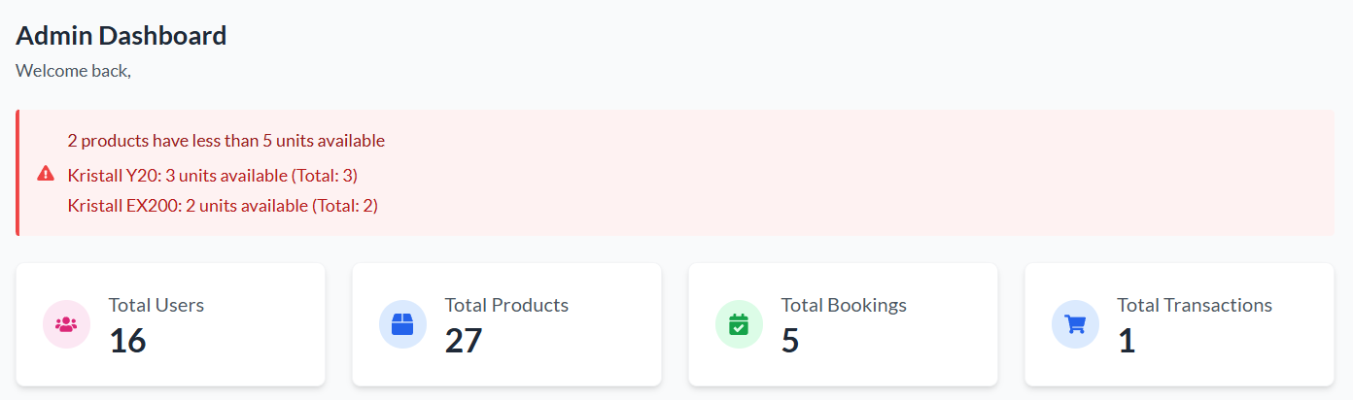

Following is the code that controls Statistical Overview on the Dashboard:

Redux queries

Code Location: frontend/src/pages/Admin/Dashboard.jsx

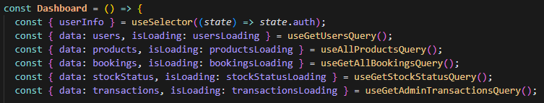

Total Users Count

Code Location: frontend/src/pages/Admin/Dashboard.jsx

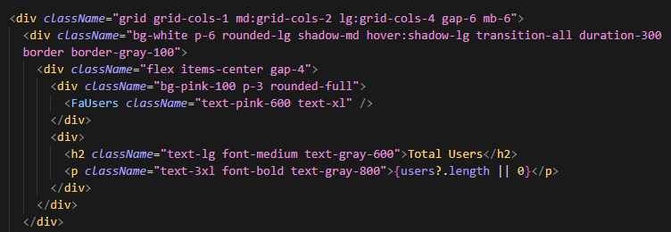

Total Products Count

Code Location: frontend/src/pages/Admin/Dashboard.jsx

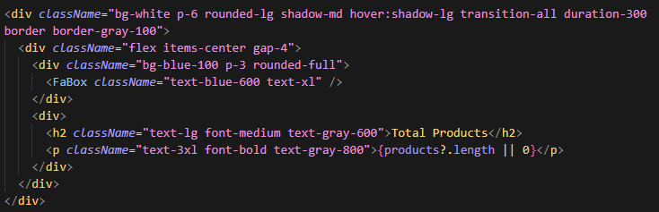

Total Bookings Count

Code Location: frontend/src/pages/Admin/Dashboard.jsx

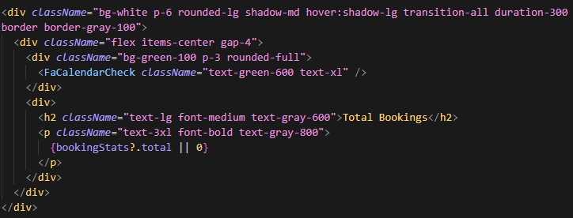

Total Transactions Count

Code Location: frontend/src/pages/Admin/Dashboard.jsx

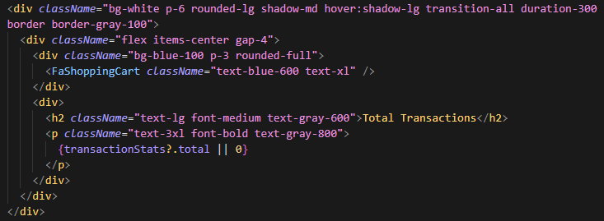

B. Financial Metrics

* Total Revenue
* Booking Revenue
* Sales Revenue
* Revenue Trends

UI View of Financial Metrics from Admin Dashboard that shows Total Revenue, Bookings Revenue and Sales Revenue.

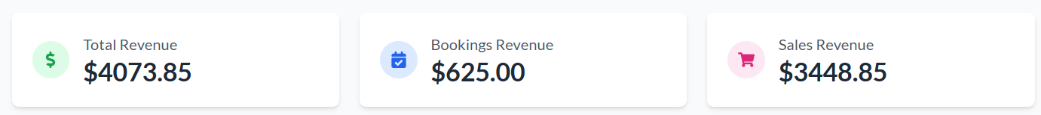

Following is the code that controls Financial Metrics on the Dashboard:

Total Revenue

Code Location: frontend/src/pages/Admin/Dashboard.jsx

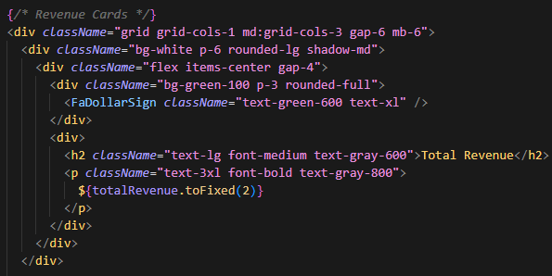

Booking Revenue

Code Location: frontend/src/pages/Admin/Dashboard.jsx

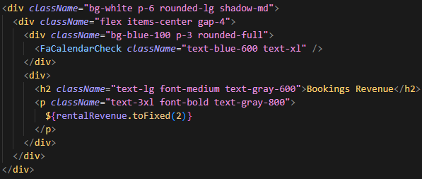

Sales Revenue

Code Location: frontend/src/pages/Admin/Dashboard.jsx

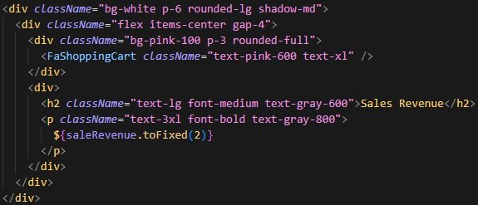

Revenue Trends

Code Location: frontend/src/pages/Admin/Dashboard.jsx

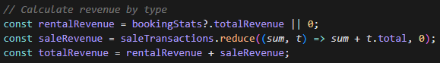

C. Inventory Management

* Low Stock Alerts
* FSN (Fast, Slow, Non-moving) Analysis
* Stock Status Monitoring

Low Stock Alerts

UI View that shows an alert for products with quantity below 5:

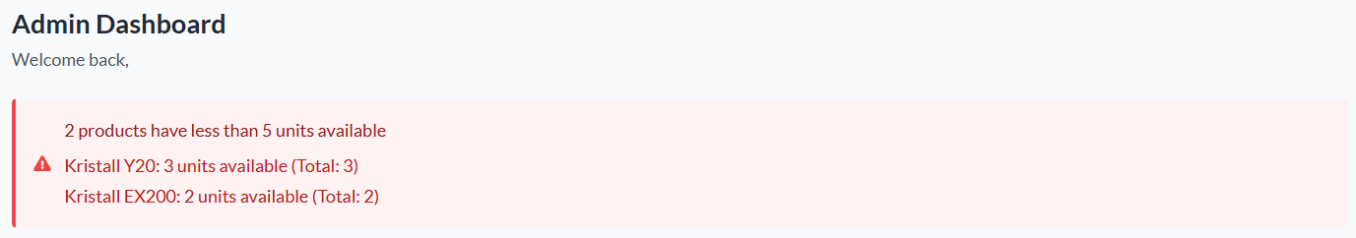

Low Stock Alerts - Frontend

Code Location: frontend/src/pages/Admin/Dashboard.jsx

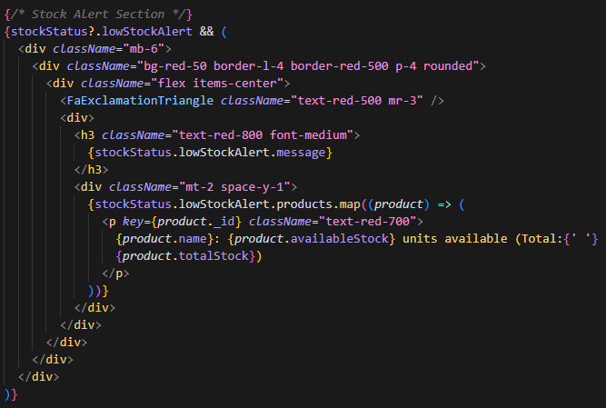

Low Stock Alerts - Backend

Code Location: backend/controllers/bookingController.js

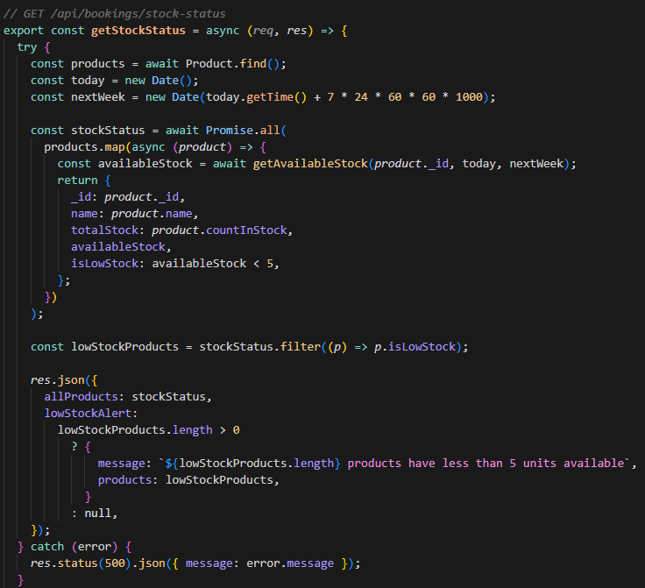

FSN Analysis

UI View of Fast, Slow and Non Moving products analysis

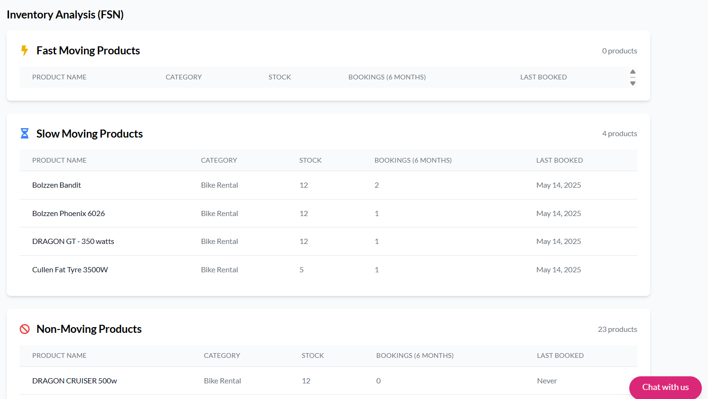

FSN Analysis - Frontend Component

Code Location: frontend/src/components/FSNAnalysis.jsx

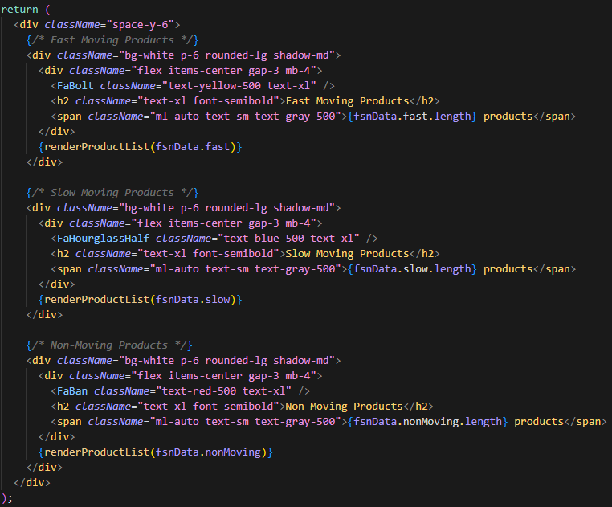

FSN Analysis - Backend Logic

Code Location: backend/controllers/productController.js

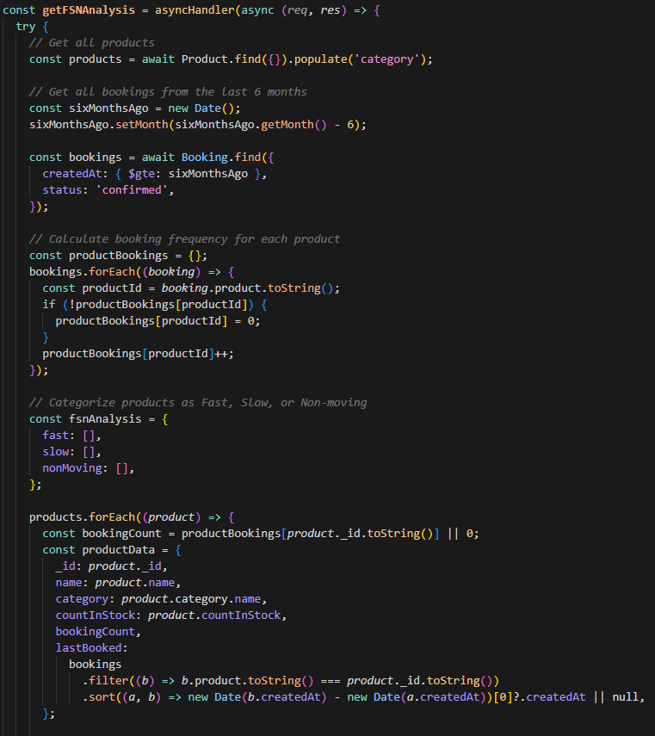

FSN Analysis - API Route

Code Location: backend/routes/productRoutes.js



FSN Analysis - Redux Query

Code Location: frontend/src/redux/api/productApiSlice.js

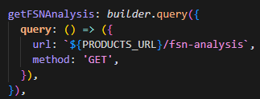

Stock Status Monitoring - Frontend Query

Code Location: frontend/src/redux/api/bookingApiSlice.js

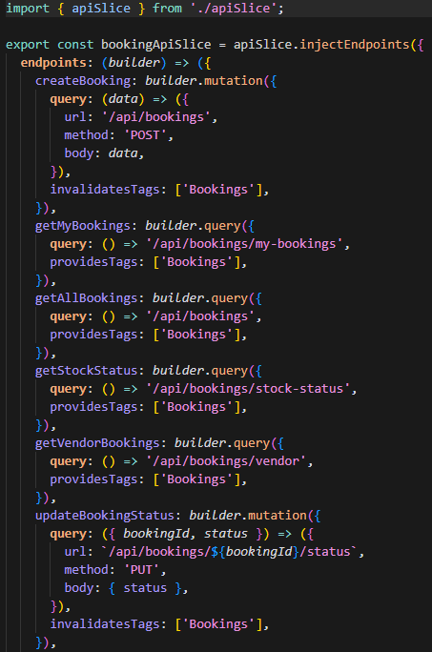

Stock Status Monitoring - Backend Route

Code Location: backend/routes/bookingRoutes.js

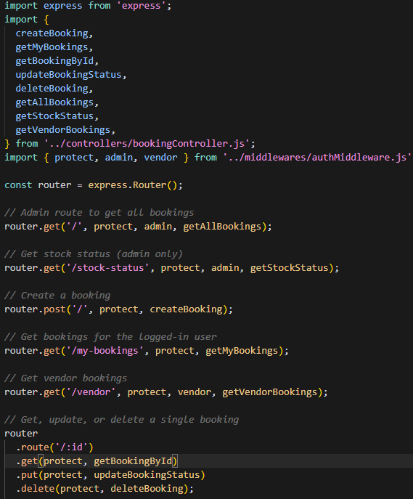

D. Recent Activities

* Latest Bookings
* Recent Transactions
* User Activities
* System Alerts

Latest Bookings

Admin Dashboard:

UI View of Recent Bookings from Admin Dashboard

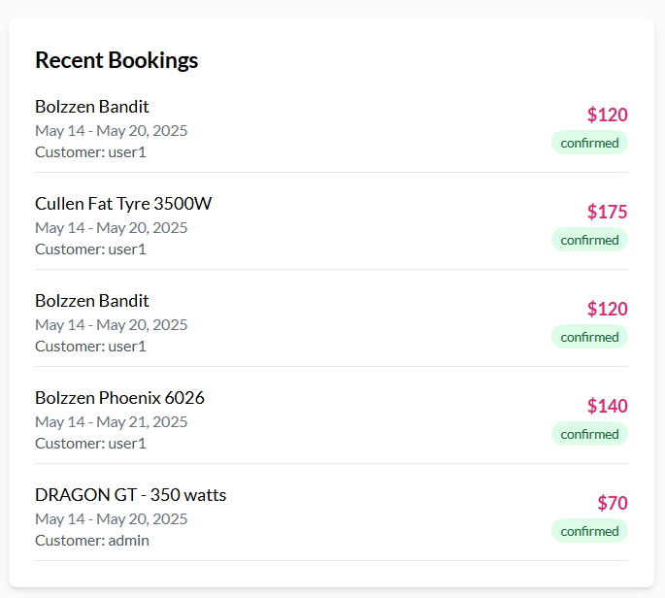

Code Location: frontend/src/pages/Admin/Dashboard.jsx

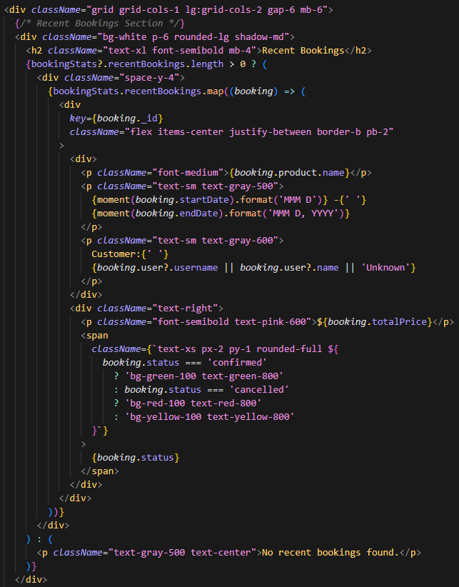

Vendor Dashboard:

UI View of Recent Bookings from Vendor Dashboard

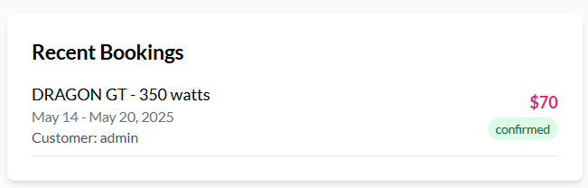

Code Location: frontend/src/pages/Vendor/Dashboard.jsx

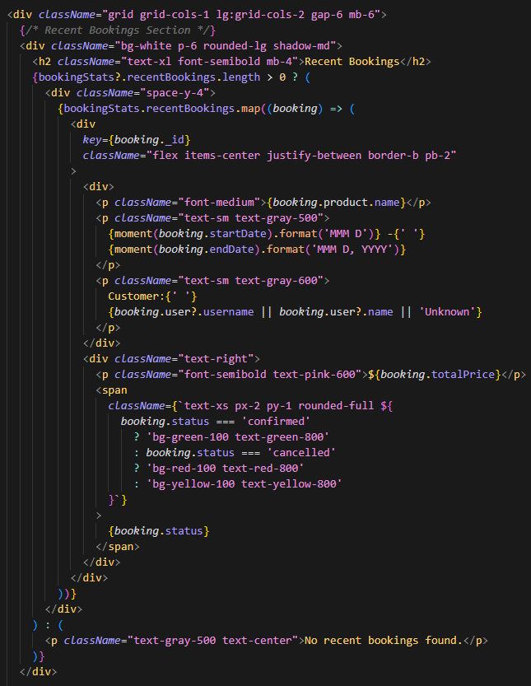

Admin Bookings Page:

UI View of Manage Bookings from Admin Dashboard

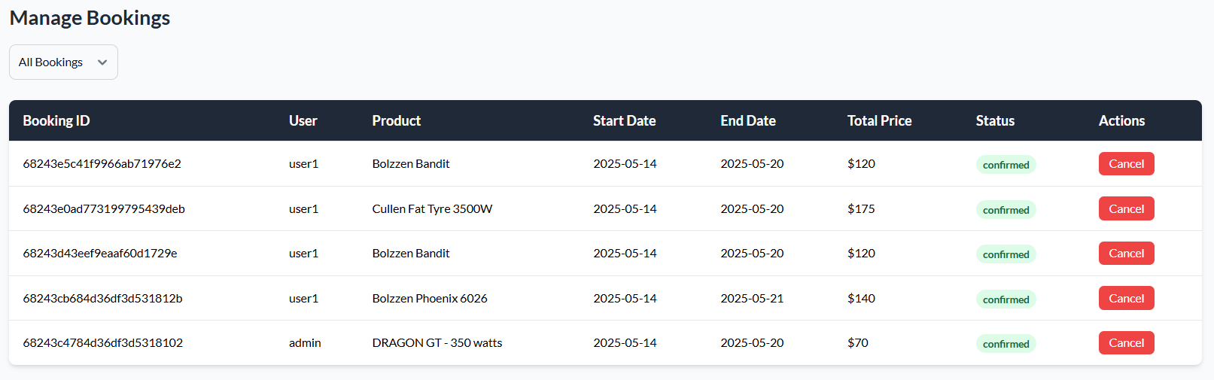

Code Location: frontend/src/pages/Admin/AdminBookings.jsx

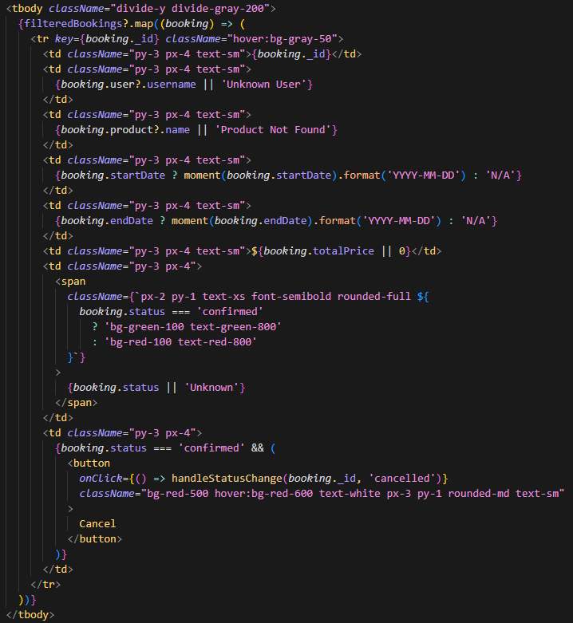

Backend Controller:

Code Location: backend/controllers/bookingController.js

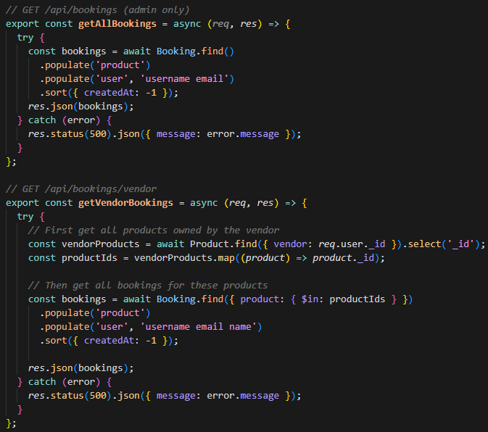

Recent Sales Transactions:

Admin Dashboard:

UI View of Recent Sales

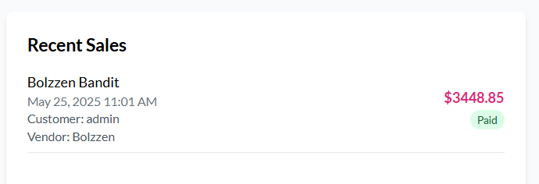

Code Location: frontend/src/pages/Admin/Dashboard.jsx

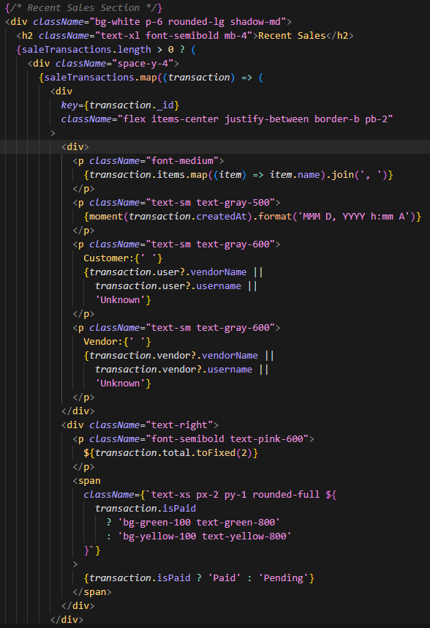

Transaction Stats Calculation:

Code Location: frontend/src/pages/Admin/Dashboard.jsx

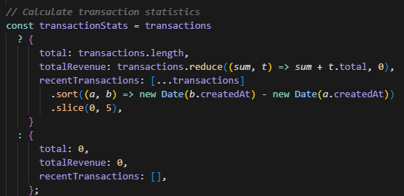

Transaction Filtering:

Code Location: frontend/src/pages/Admin/Dashboard.jsx



User Activities:

UI View that shows User Details such as Basic Information, Rental Statistics and Rental History.

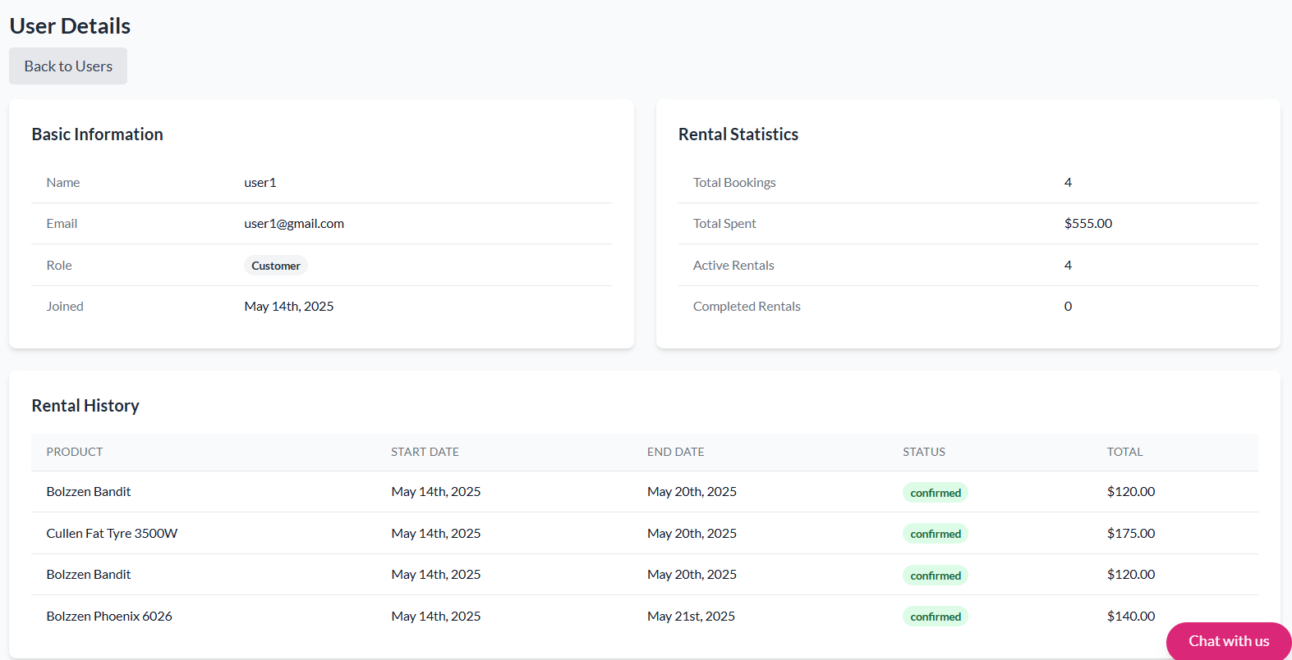

Code Location: frontend/src/pages/Admin/UserDetails.jsx

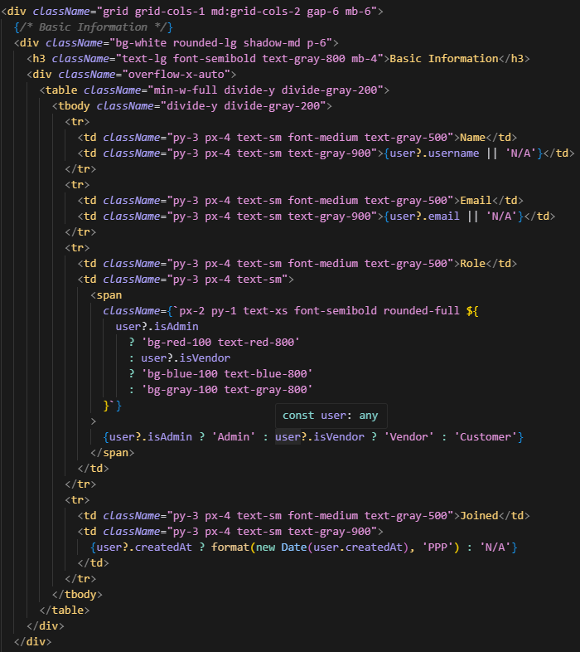

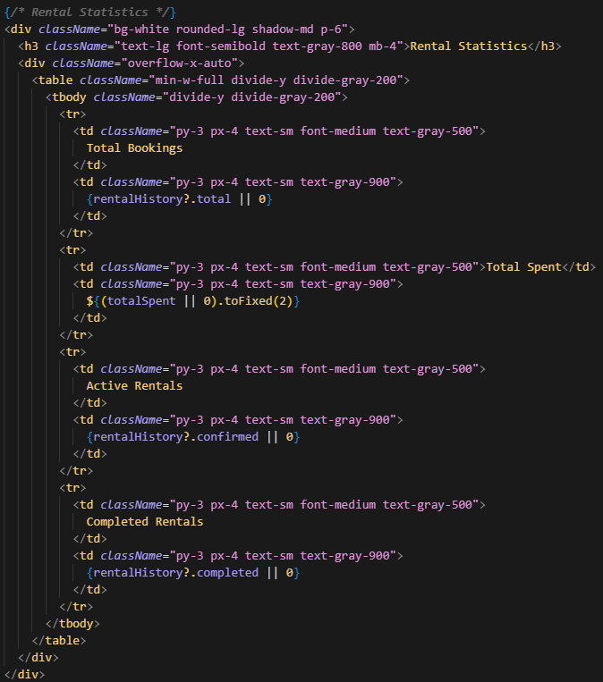

User Controller: backend/controllers/userController.js

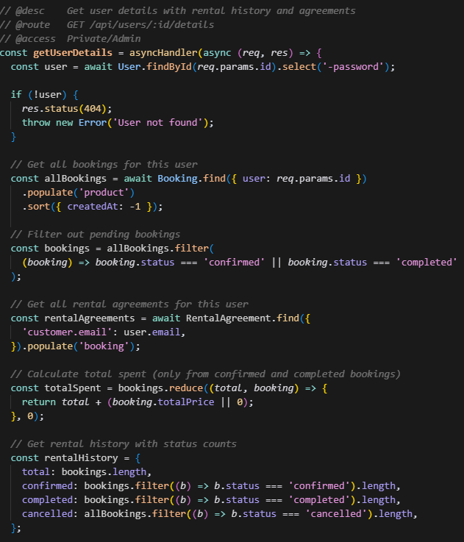

My Bookings:

UI View of My Bookings Page

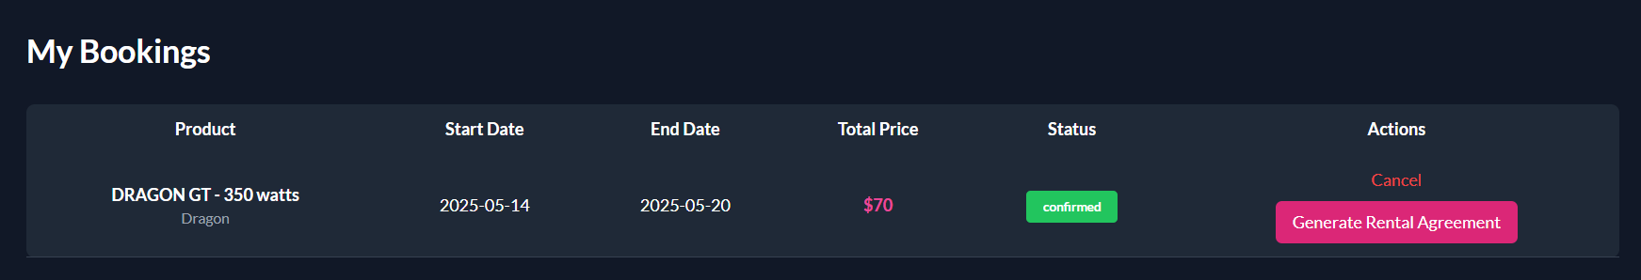

Code Location: frontend/src/pages/MyBookings.jsx

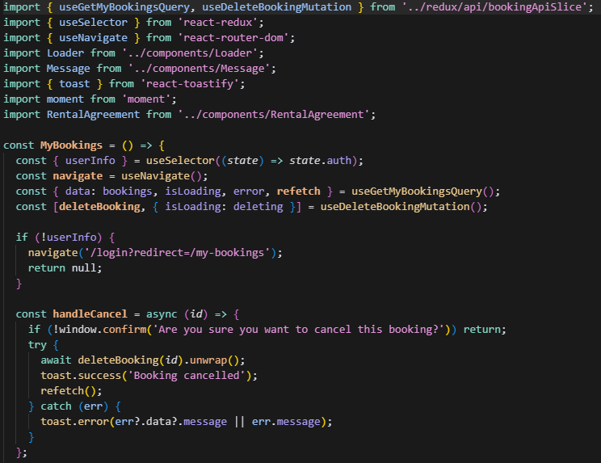

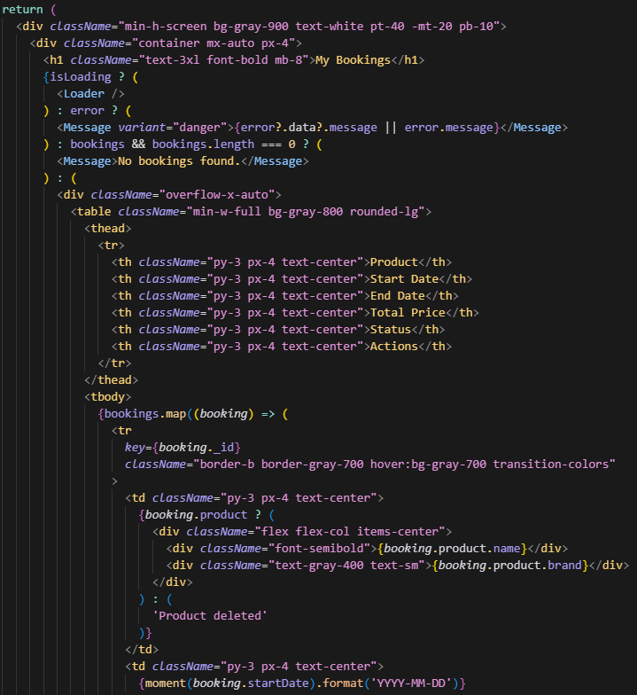

System Alerts:

Booking Status Alerts: frontend/src/pages/Admin/AdminBookings.jsx

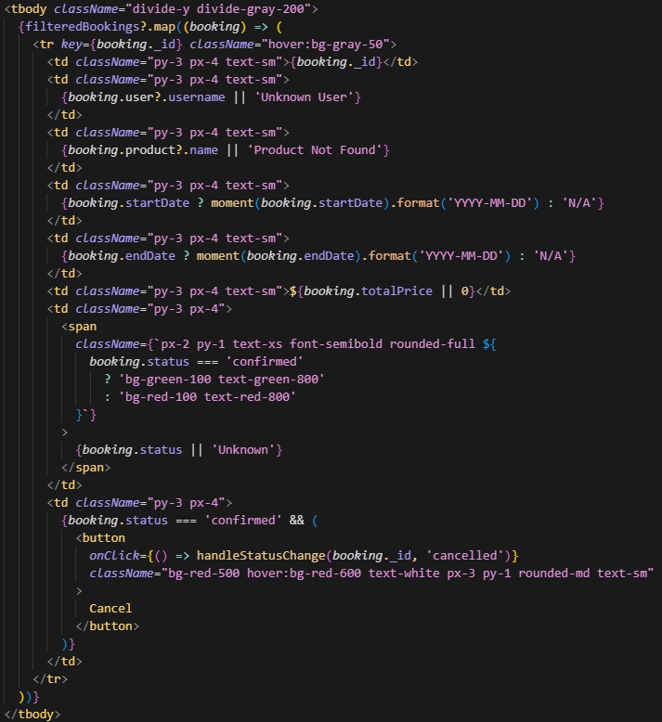

Vendor Bookings: frontend/src/pages/Vendor/VendorBookings.jsx

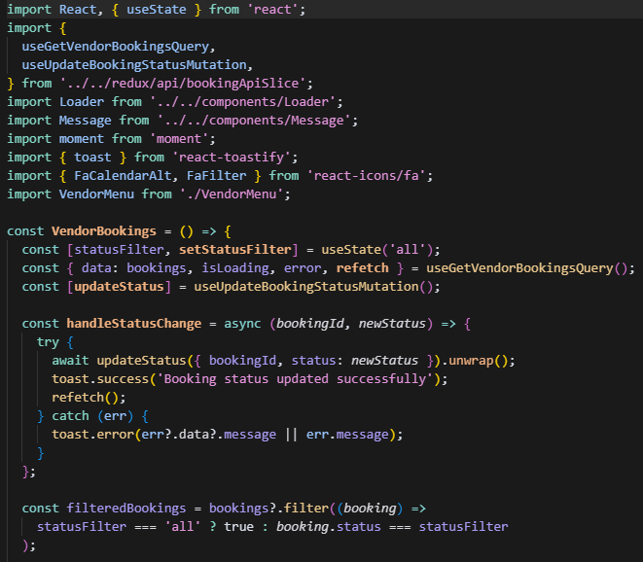

##### **Users Module**

Purpose:The Users Module provides comprehensive user management capabilities, allowing administrators to monitor, manage, and control user accounts and their activities.Key Features:

1. User Management

* User Listing
* User Search
* Role Management
* Account Status Control

1. User Details

* Basic Information
* Role Information
* Activity History
* Account Status

1. Access Control

* Role-based Permissions
* User Status Management
* Access Level Control

##### **Update Details Module**

Purpose: The Update Details Module manages product information, inventory, and content updates across the system.

**Key Features:**

Content Management

* Product Descriptions
* Images
* Categories
* Specifications

UI View for updating a product. It includes Delete Product functionality. On this page admin/vendor can upload product image, name, brand, description, rental price, sale price, stock count, size, color, and category.

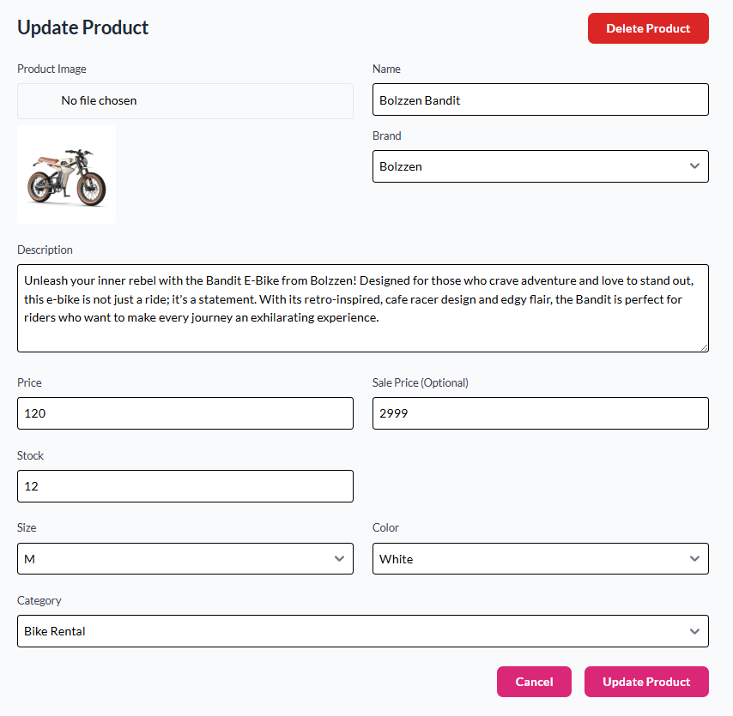

Product Descriptions

Code Location: frontend/src/pages/Admin/ProductUpdate.jsx

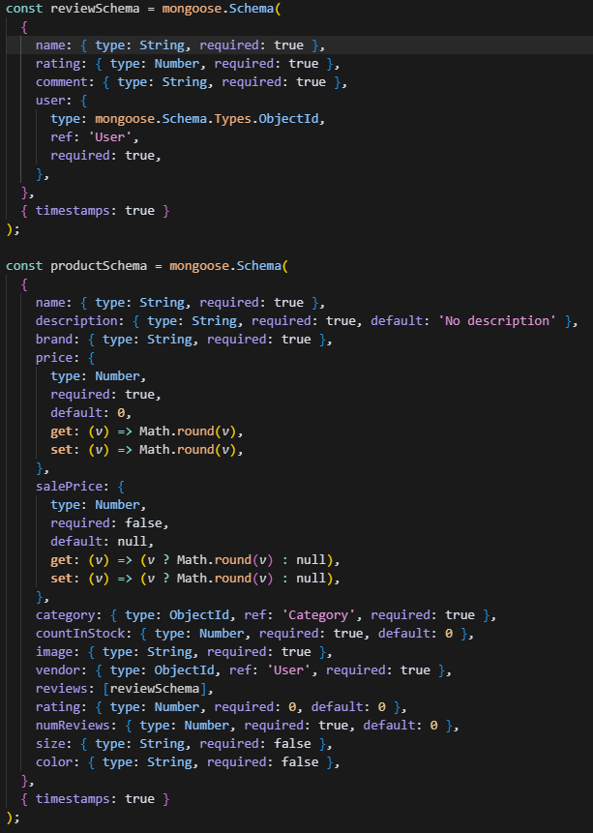

Product Description - Description Display

UI View of Product Description

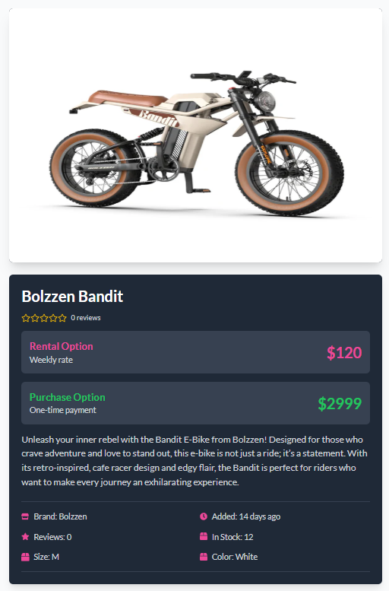

Code Location: frontend/src/pages/Admin/AllProducts.jsx

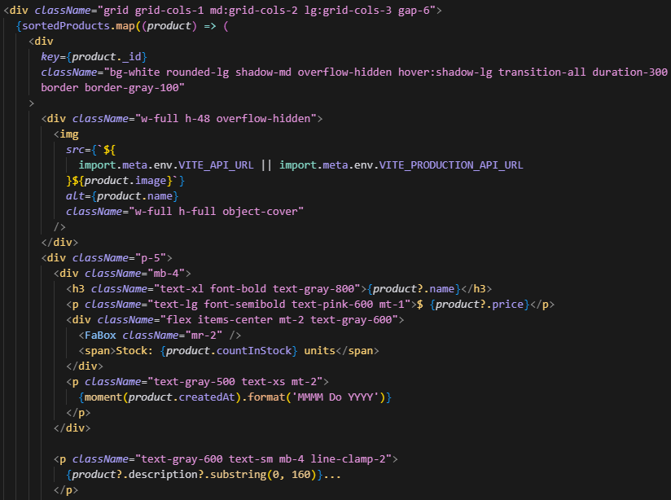

Images:

Code Location: backend/controllers/productController.js

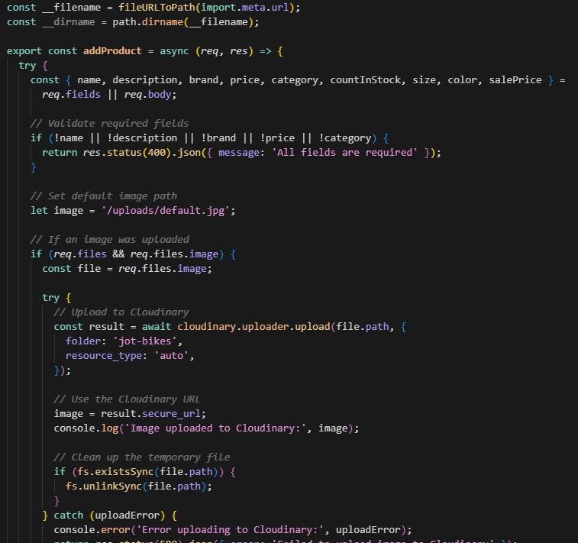

Image upload: backend/controllers/vendorController.js

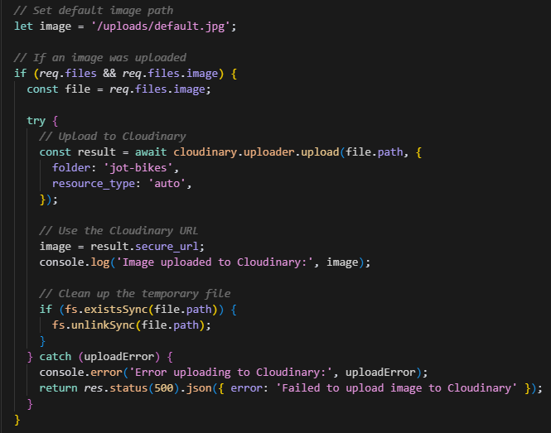

Image display: frontend/src/pages/Admin/ProductGrid.jsx

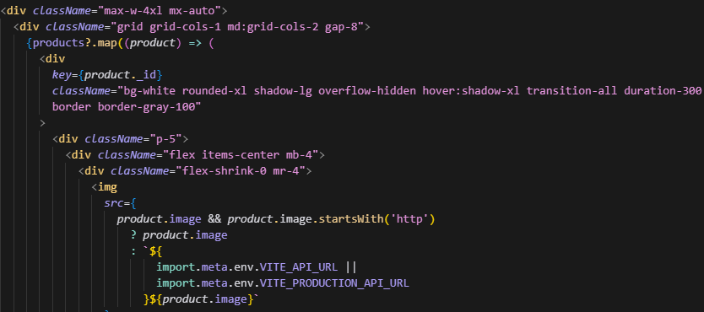

Categories:

Code Location: frontend/src/pages/Admin/ProductList.jsx 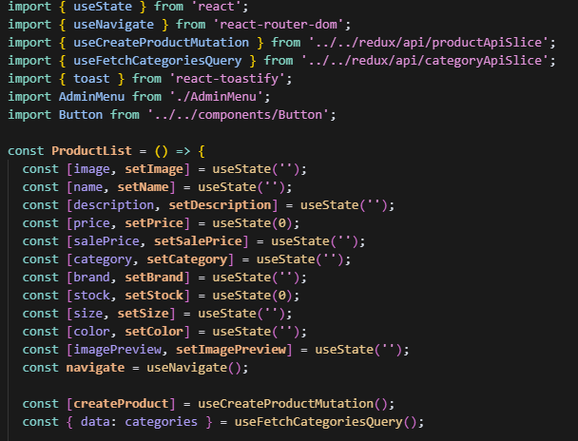

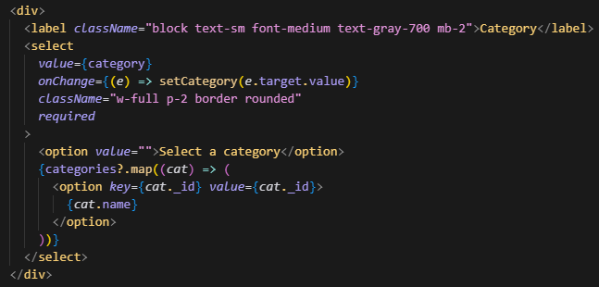

Category management: frontend/src/pages/Vendor/AddProduct.jsx

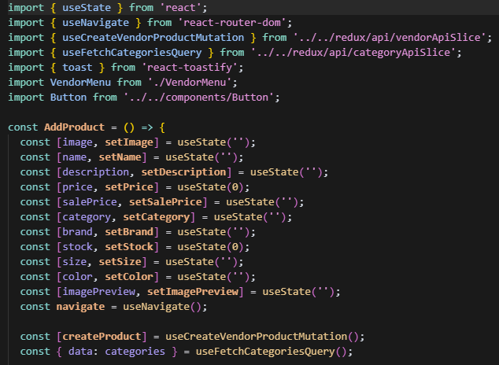

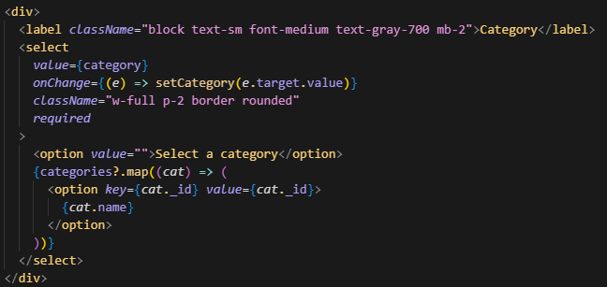

Specifications:

Code Location: backend/models/productModel.js

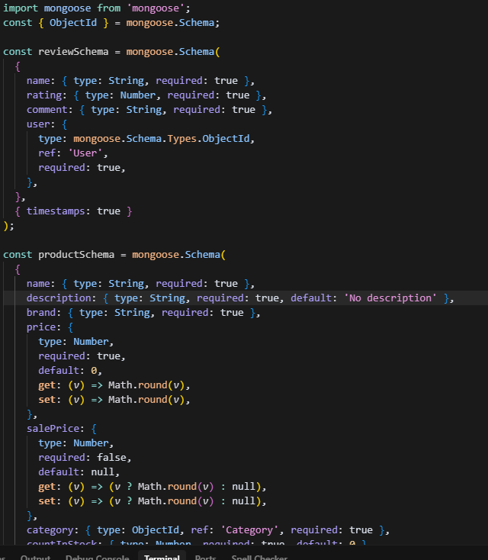

Specification display: frontend/src/pages/Vendor/Products.jsx

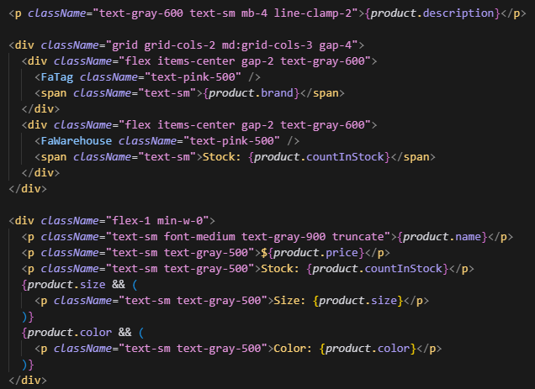

Inventory Control

* Stock Updates
* Price Modifications

UI View where admin/vendor can update stock level and prices.

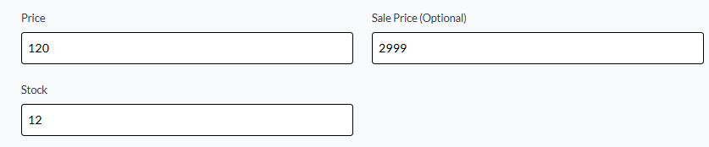

Stock Updates:

Code Location: frontend/src/pages/Vendor/VendorProductUpdate.jsx

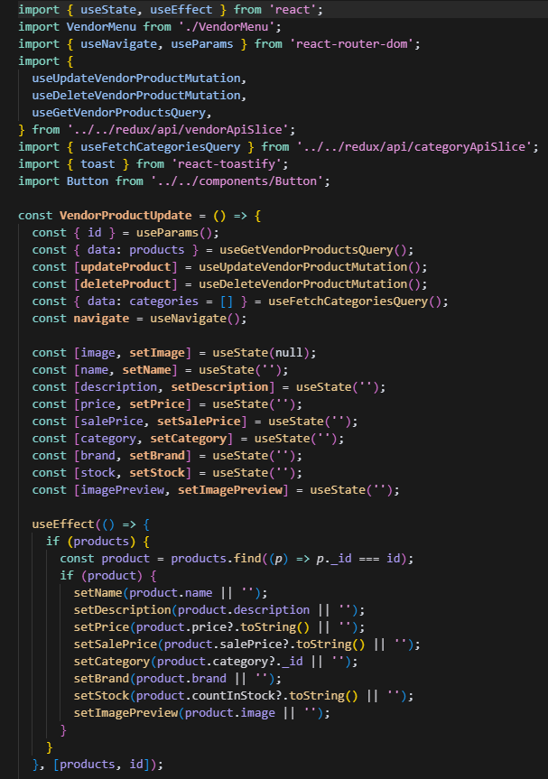

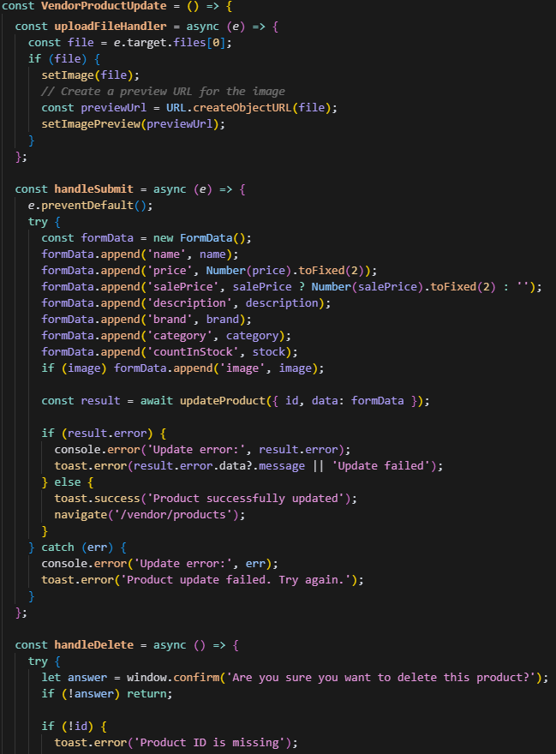

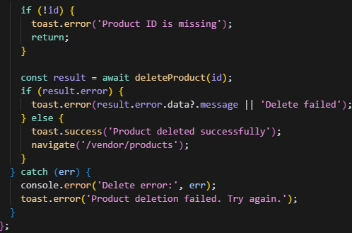

Stock display: frontend/src/pages/Admin/AllProductsList.jsx

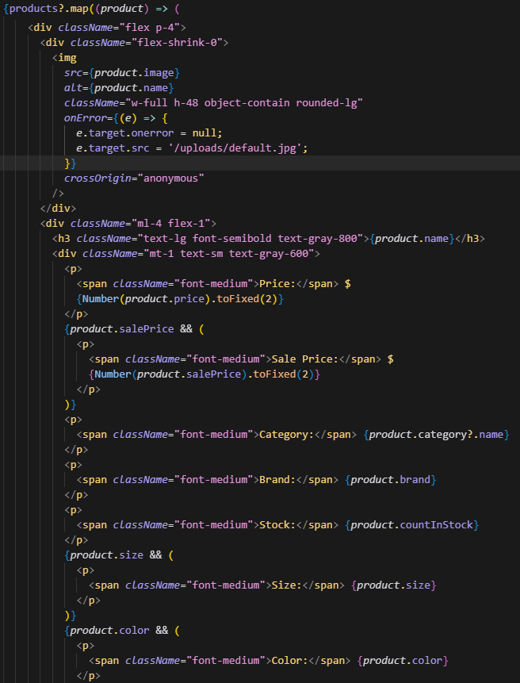

Price Modifications:

Location: frontend/src/pages/Admin/ProductUpdate.jsx

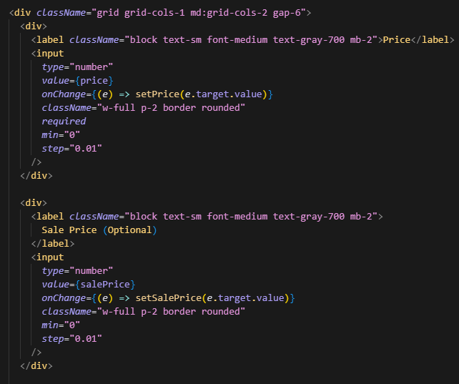

Price updates: frontend/src/pages/Vendor/VendorProductUpdate.jsx

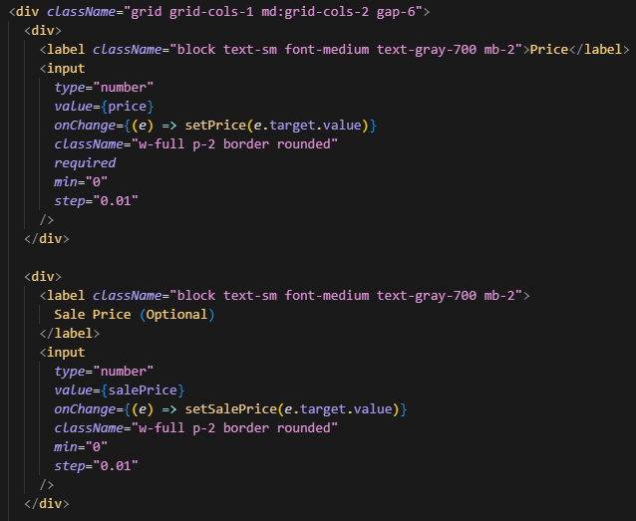

##### **Edit and Update User Module**

UI view for editing a user as an admin.

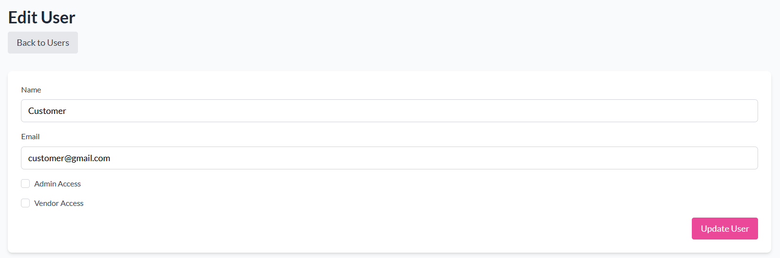

Frontend Components:

frontend/src/pages/Admin/UserEdit.jsx

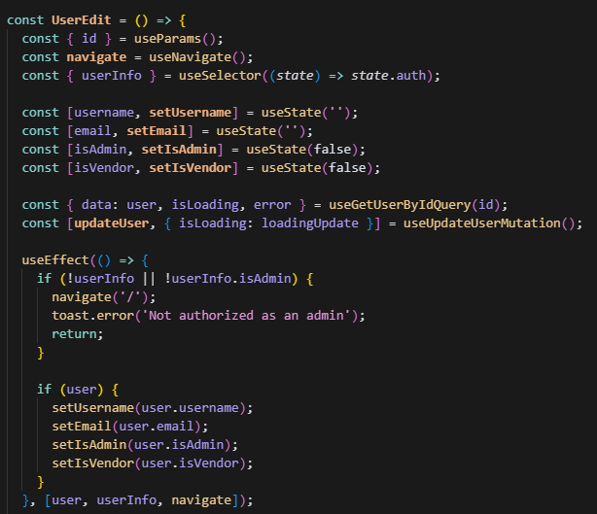

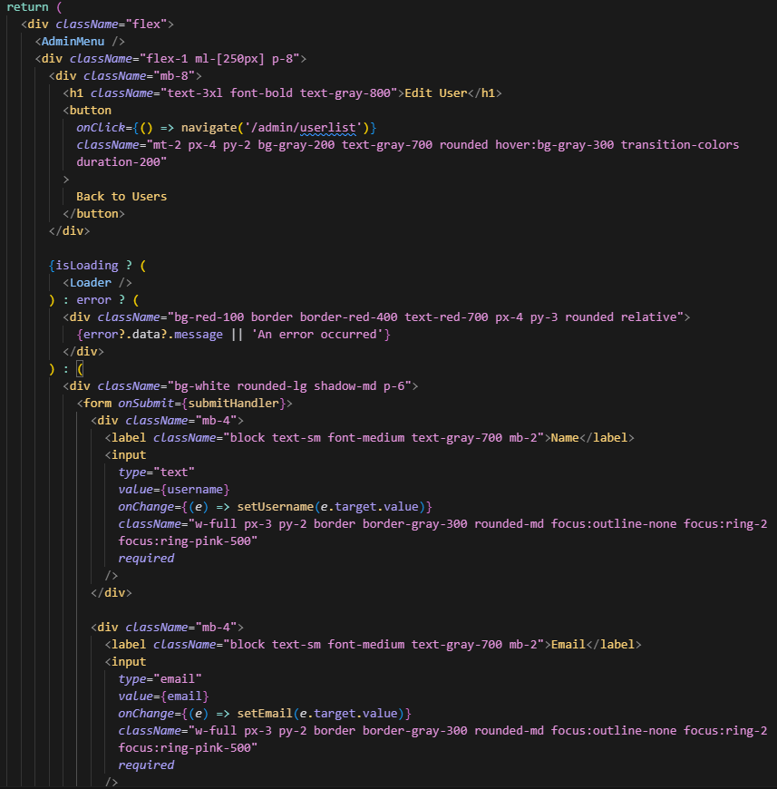

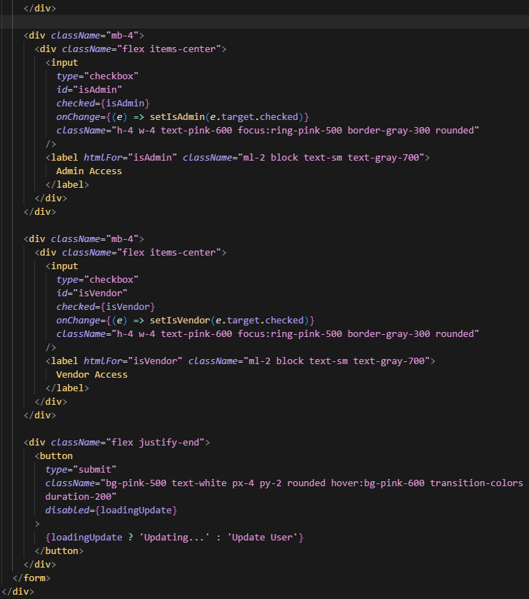

##### **Update Profile**

UI view for updating profile

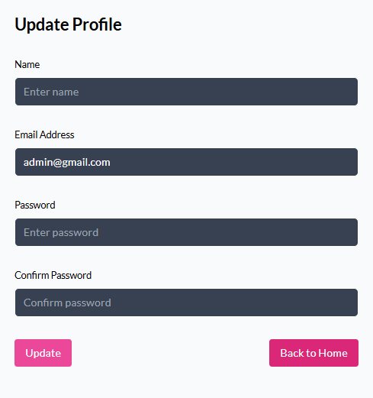

Frontend Profile Update Component

Code Location: (frontend/src/pages/User/Profile.jsx)

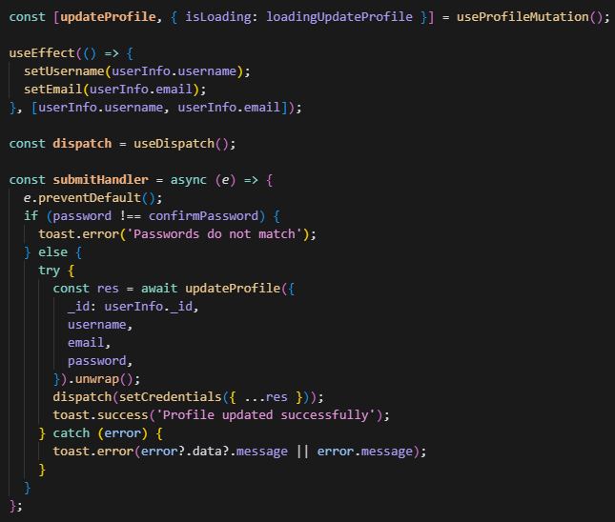

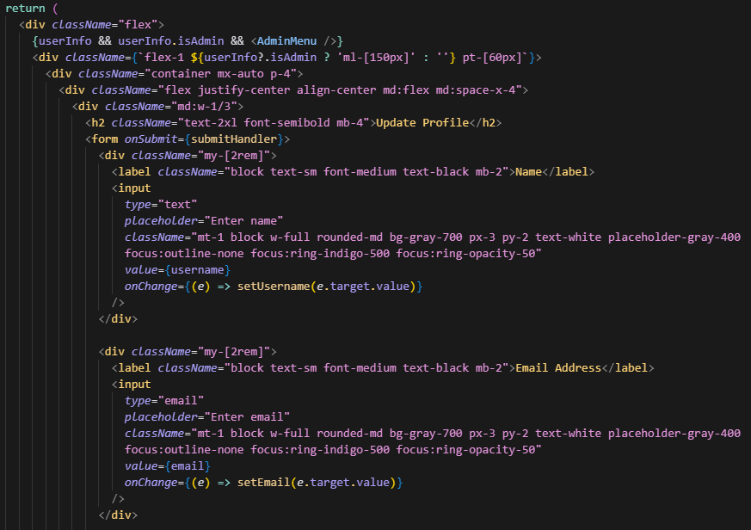

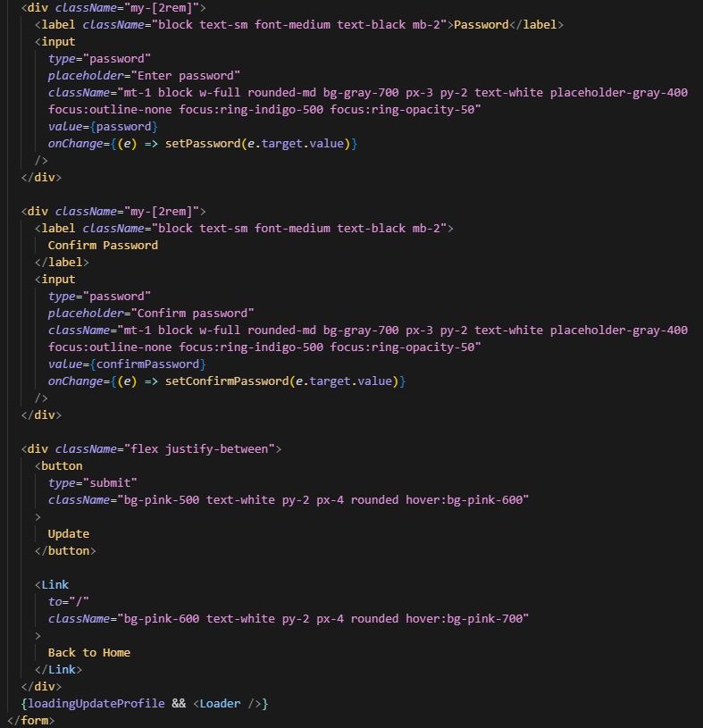

Backend User Controller

Code Location: (backend/controllers/userController.js)

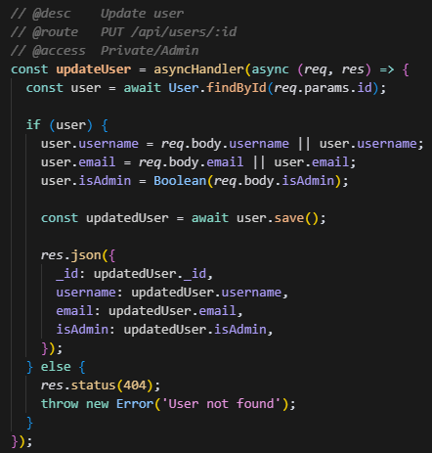

Backend User Routes

Code Location: (backend/routes/userRoutes.js)

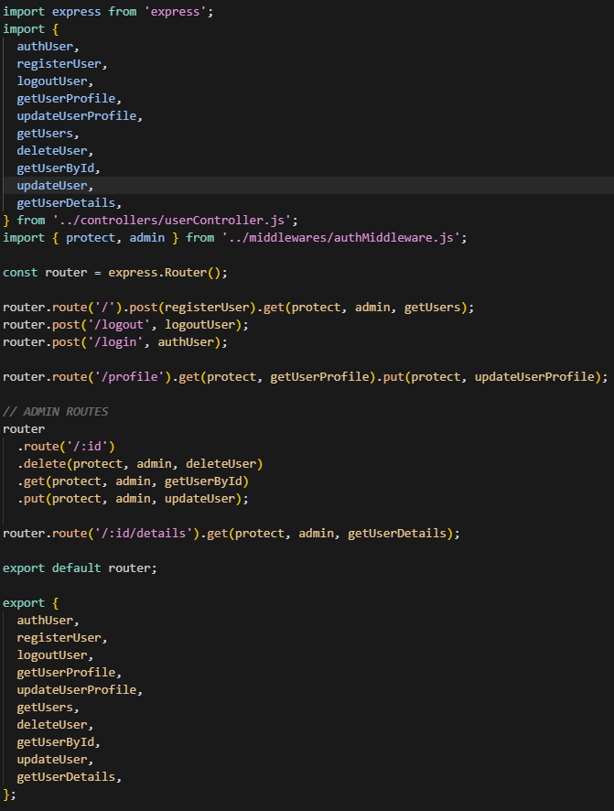

Frontend API Slice

Code Location: (frontend/src/redux/api/usersApiSlice.js)

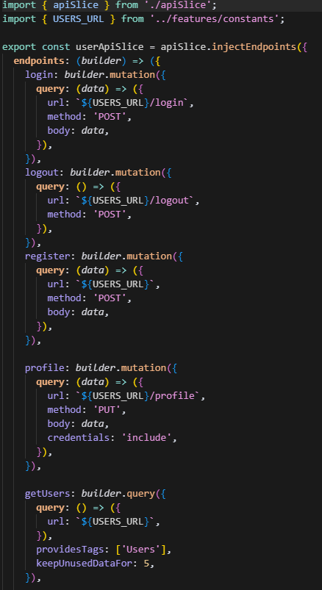

Admin User Management

Code Location: (frontend/src/pages/Admin/UserList.jsx)

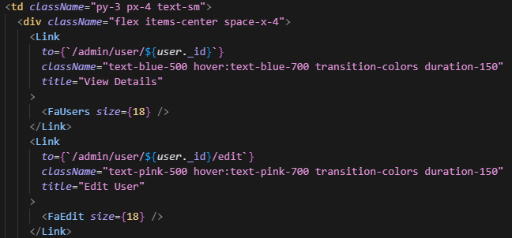

Vendor Profile Update

Code Location: (backend/controllers/vendorController.js)

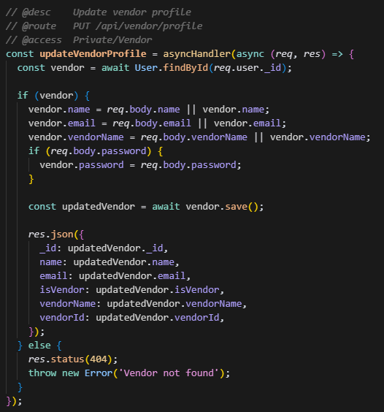

##### **Delete User Module**

Delete User - Frontend

Code Location: frontend/src/pages/Admin/UserList.jsx

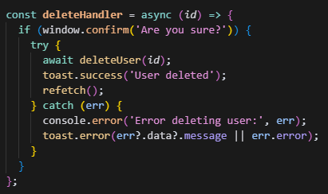

Delete User - Backend

Code Location: backend/controllers/userController.js

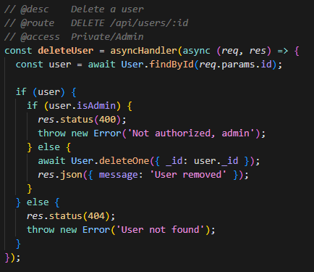

## **8. Implementation and Management**

### **Implementation Plan**

#### **Steps and timelines for implementation**

The JBMS (Jot Bikes Management System) follow the agile methodology and will be delivered in six two-week sprints. Each sprint begins with a sprint planning which allow the allocation of task to be divided thoroughly to each individual member based on their skill set. This is done to improve the overall efficiency as there is a tight deadline toward the progress of this project. Which is then supported by weekly stand-up and sprint review that is held in class every Tuesday to follow up on the task assigned and any problem encountered. The main communication channel for the JBMS project is WhatsApp, but for documentation and visibility purposes GitHub is the primary choice.

The JBMS project spans for 11 weeks, matching the course assessment schedule. While building features for the JBMS, the team will also be preparing and submitting major report accordingly.

Week 3: Initial SRS

Week 5: Final SRS

Week 6: Presentation

Week 9: Mid Project Deliverable

Week 11: Final Project Deliverable

Week 12: Project Demo

JBMS is delivered with six two-week sprints which detailed as follow

Sprint 1: Foundation & Environment

This sprint occurs from week 1-2

Objectives:

* Configure development infrastructure
* Establish CI/CD pipelines
* Secure environment for development and staging
* Identify functional and non-functional requirement

Key Task:

* Sprint planning & backlog grooming
* Provision GitHub repository
* Set up MongoDB Atlas cluster
* Configure Vercel and Render
* Document environment variables and access procedure
* Drafting up the initial SRS document

Deliverables:

* Created GitHub repository <https://github.com/HendraLim1/ProjectCapstone>
* Created Website link <https://jot-bikes-capstone.vercel.app>

Roles:

* Project Manager leads planning
* Lead Developer initiate website development
* Team work on drafting initial SRS per requirement

Sprint 2: Authentication & Authorization

This sprint occurs from week 3-4

Objectives:

* Implement secure user registration, login, and email verification
* Enforce Role Based Access Control (RBAC)
* Provide “Forgot Password” and reset flow

Key Task:

* Design User schema in MongoDB
* Build Express routes for /signup, /login, /verify-email, /reset-password
* Integrate bcrypt for hashing and jsonwebtoken for JWT session
* Create react forms with client-side validation
* Submit Initial SRS by end of week 3
* Start drafting of Final SRS

Deliverables:

* Demo of live sign up and dashboard access
* Fully tested signup, login, and reset flow (Vendor, Admin, Customer)
* Initial SRS report <https://github.com/HendraLim1/ProjectCapstone/blob/report-development/WIP%20Report/Group%204%20Initial%20SRS.docx>

Roles:

* UX/UI for wireframe and website design
* Lead Developer construct website code with project manager
* Team work on drafting Final SRS per requirement
* Data analyst work on test cases

Sprint 3: Product Management

This sprint occurs from week 5-6

Objectives:

* Enable Vendor/Admins to CRUD bike listings
* Support image uploads
* Display listing in the public shop

Key Task:

* Define product schema
* Develop react pages for create product, my product and shop listings
* Research for vendor/product to be added to the website
* Submit Final SRS report
* Prepare presentation slides

Deliverables:

* Responsive shop page
* Final SRS report <https://github.com/HendraLim1/ProjectCapstone/blob/report-development/WIP%20Report/Group%204%20Final%20SRS.docx>
* Presentation Slide

Roles:

* UX/UI developer collaborate with Lead developer on website design
* Business Development Manager liaise with vendor
* Data analysts collect vendor data

Sprint 4: Booking & Payments

This sprint occurs from week 7-8

Objectives:

* Implement booking workflow with availability checks
* Integrate Stripe for payments
* Send confirmation emails and update booking status

Key Task:

* Create Booking schema
* Build /bookings API with transactional logic to prevent overbooking
* Integrate Stripe Elements in react for secure payment UI
* Develop booking page for customer and booking view for vendors/admins

Deliverables:

* End to end booking + payment demo
* Booking API documentation
* Test scripts for concurrent booking scenarios

Roles:

* Lead Developer integrate Stripe UI
* Data Analyst validate pricing rule
* Team testing booking concurrency

Sprint 5: Dashboard

This sprint occurs from week 9-10

Objectives:

* Build analytic summaries for admins
* Polish UI/UX across all dashboards

Key Task:

* Build admin feedback table with reply functionality
* Ensure pages are responsive and accessible
* Draft up the Mid deliverable report

Deliverables:

* Fully functional website with pending final testing
* Mid Deliverable report <https://github.com/HendraLim1/ProjectCapstone/blob/report-development/WIP%20Report/Group%204%20Mid%20Deliv.docx>

Roles:

* Team work together on allocated task

Sprint 6: Final Testing

This sprint occurs from week 11

Objectives:

* Conduct a full manual testing
* Conduct User Acceptance Testing

Key Task:

* Upload all code to a separate GitHub for cleanliness and visibility
* Work on Final deliverable report
* Work on Poster for Week 12 Demo

Deliverables:

* Fully functional website with pending final testing
* Final Deliverable report

Roles:

* Team work together on allocated task

### **Project Management**

#### **Management Strategies and Tools**

JBMS follow the agile scrum approach which give the team room to adapt to evolving requirements while also ensuring continuous delivery of working software. The project has been broken down into six two-week sprints

Communication

* Weekly Sprint Ceremonies are held in person every week to ensure alignment on scope and task distribution
* WhatsApp Group is also created for urgent notification and quick clarification
* GitHub Discussion are used to note down each individual task to keep a visibility on tracking each other progress

#### **Project Management Tools**

* Version Control is enforced via protected branches on GitHub; every feature or fix is delivered through a pull request that requires at least one peer review and successful CI build before merging
* Figma is used for our UI prototypes document design feedback and sign-off to ensure implemented UI match the approved mockups

#### **Team roles and responsibilities**

|  |  |  |
| --- | --- | --- |
| Name | Job title | Responsibilities |
| Hendra | Project manager | * Plan project scope, schedule, and resources * Assign tasks and manage team performance * Ensure deliverables meet quality and business requirement * Ensure project is delivered in time * Facilitate testing and user acceptance * Oversee final delivery and project closure |
| Erna | Lead Developer | * Design and oversee the architecture of the system * Conduct code reviews to maintain code quality, consistency, and security. * Collaborate with the project manager to understand project requirements and timelines * Troubleshoot issues * Integrate front-end and back-end components with the database and third-party systems * Ensure system performance, security, and maintainability throughout the development lifecycle |
| Thi | UX/UI Designer | * Conduct user research to understand target audience needs * Design visually appealing interfaces aligned with brand guidelines * Develop interactive prototypes to test design concepts and workflows * Collaborate with developers to ensure accurate design implementation * Conduct usability testing and iterate designs based on user feedback * Ensure consistent and accessible user experience across all devices and screen sizes |
| Wangshu | Data Analyst | * Analyse data to identify usage patterns, customer trends and business management * Generate regular reports and visual dashboards for stakeholders and management * Collaborate with developers to ensure data accuracy and integrity in system logs. * Ensure compliance with data privacy and protection policies |
| Alyxandra | Business Development Manager | * Identify and pursue new partnership opportunities with vendors, service providers, and strategic partners * Develop and implement strategies to increase customer acquisition and business growth * Promote the Jot Bikes platform to expand brand presence and user base * Conduct market research to understand industry trends and customer needs * Collaborate with marketing and sales teams to foster long-term collaboration * Provide input on pricing models, service offerings, and customer experience improvements |

## **9. Ethical Thought**

The Jot Bikes Management System (JBMS) was built around the principle of privacy-by-design. Only data with a clear business purpose is collected, and every attribute in the schema is mapped to an Australian Privacy Principle (APP) lawful basis. All personal information is encrypted at rest with AES-256 and exposed only through role-based access controls that distinguish Customers, Vendors and Admins.

The web interface reinforces those values. Consent prompts are written in plain language, presented with equal weight “Accept” and “Decline” buttons, and no tracking cookies are set until the user opts in. Screens are tested each sprint against WCAG 2.2 AA accessibility criteria, ensuring that people of all abilities can navigate the service without coercion or “dark patterns.”

Ethical thinking also shapes the system architecture. Threat-modelling workshops precede every major design change, and the resulting controls—input validation, least-privilege IAM roles, secret rotation—are enforced through OWASP ASVS Level 2 gates in CI/CD. A serverless deployment model and low-carbon scheduling of nightly batch jobs reduce the environmental footprint, while multi-AZ fail-over and a tested disaster-recovery plan provide resilience and accountability throughout the platform life cycle.

Together, these measures embed security, transparency, sustainability and professional integrity into the database layer, the user experience and the underlying infrastructure—fulfilling the ethical expectations set by the APPs, ISO 27001, WCAG 2.2 and the ACS Code of Professional Conduct.

## **10. Feedback**

The team has received few initial feedback from the lecturer regarding the content of the report.

1. The team had express concerned regarding the visibility of the code layout structure in the report, as it will affect the readability. Hence, the recommendation was to provide a GitHub link toward the code and attach screenshot for each and individual section of the code.
2. The team has shared minor concern regarding the reference for the report, as this project was built progressively, hence in this documentation there is a lack of in-text reference. It was suggested to use reference from previous report.

GitHub Link to the Code: <https://github.com/erna-h33/jot-bikes>

GitHub Link to the document: <https://github.com/HendraLim1/ProjectCapstone/blob/report-development/WIP%20Report/6.%20Final%20Deliverable.docx>

Website Link: <https://jot-bikes-capstone.vercel.app>

## **11. Final Evaluation**

The JBMS has been developed considering functional and non-functional requirements. The requirements in the specification are:

* Inventory Management: Bike inventory tracking, add or remove products, alerts for low stock.
* Rent Management: Includes online reservations, rental contracts, lease processing, and check-in/out.
* Sales Management: You can show products which are currently for sale or rent, and then it will be processed and saved securely.
* Customer Relationship Management: Profiles will become one-to-one, meaning automated sends around bookings and promotions to customer databases for example.
* Reporting & Analytics: The solution will produce sales, rental, inventory reports to help business owners understand their business performance. NFRs focus on responsiveness, privacy, security, scalability, reliability, and maintainability. System Architecture The system is built with the MERN stack (MongoDB, Express. js, React. js, Node. js) for full seamless integration and rapid development. Dicas de segurança Passwords are hashed using bcrypt, AES-256 for data at rest and RBAC the sensitive data safe and in compliance with industry standards. The software will also feature a notice system that users are updated on bookings and payments. UI has been taken into consideration to provide best experience possible to the user, TailwindCSS has been used to make it responsive more. The implementation plan is phased in nature and the system will have to be tested well and users will have to be well trained after the installation.

## **12. Conclusion**

Jot Bikes Management System is a major processing and backend system update for Jot Bikes. Addressing the shortcomings of the existing manual systems, JBMS will improve customer satisfaction, simplify vendor management, and enrich the business with reports and analytics. Speed: Security, UX and Best Practice Speed of the existing has been heavily emphasized in development, making the current solution a strong, scalable option for the future. With the JBMS successfully in place, Jot Bikes will be in a great position to take the electric bike and scooter rental sector by storm as the customer base explodes. In addition, as the system is modular, it can be further developed to include vendor-based pricing models, promotion rules, etc without major system wide changes. This flexibility means Jot Bikes can remain adaptable and continue to respond to market trends and customer requirements.

**References**

Beck, K 2001, *Principles behind the Agile Manifesto*, Agilemanifesto.org.

Evans, E 2003, ‘Domain-Driven Design: Tackling Complexity in the Heart of Software by Eric Evans Software’.

Grassi, PA, Garcia, ME & Fenton, JL 2017, ‘Digital Identity Guidelines’, *NIST Special Publication 800-63-3*.

Kopp, T, Baumgartner, M & Kinkel, S 2020, ‘Success factors for introducing industrial human-robot interaction in practice: an empirically driven framework’, *The International Journal of Advanced Manufacturing Technology*, vol. 112, no. 3-4, pp. 685–704.

Meta n.d., *React*, react.dev.

*MongoDB Courses and Trainings | MongoDB University* 2025, Mongodb.com, viewed 18 May 2025, <https://learn.mongodb.com/pages/data-modeling-toolkit>.

OpenAI n.d., *OpenAI API*, platform.openai.com.

OWASP 2024, *OWASP Application Security Verification Standard*, owasp.org.

Project Management Institute 2021, *A Guide to the Project Management Body of Knowledge : (PMBOK guide)*, 7th edn, Project Management Institute, Newtown Square, Pa.

Sandhu ', R, Coyne, E, Feinstein, H & Youman, C 1996, ‘Role-Based Access Control Models’, *IEEE Computer*, vol. 29, no. 2, pp. 38–47.

Stellman, A & Greene, J 2017, *Head First Agile*, ‘O’Reilly Media, Inc.’

*Tailwind CSS - Rapidly build modern websites without ever leaving your HTML.* n.d., tailwindcss.com.

Team, MD 2025, *Install MongoDB Community Edition*, Mongodb.com, viewed 14 April 2025, <https://www.mongodb.com/docs/manual/administration/install-community/>.

Vipul A. M; Prathamesh Sonpatki 2016, *ReactJS by Example - Building Modern Web Applications with React*, Packt Publishing.